World Heritage | 29 COM
Distribution limited | WHC-05/29.COM/15  Paris, 30 June 2005  Original: English/French

UNITED NATIONS EDUCATIONAL, SCIENTIFIC AND CULTURAL ORGANIZATION

CONVENTION CONCERNING THE PROTECTION OF THE WORLD
CULTURAL AND NATURAL HERITAGE

WORLD HERITAGE COMMITTEE

Twenty-ninth Session

Durban, South Africa
10-17 July 2005

Item 15 of the Provisional Agenda: Report on the execution of the Budget 2004-2005 and follow-up to the recommendations concerning the administrative and financial issues of the Audit of the World Heritage Centre undertaken in 1997

SUMMARY

In accordance with Article 4.1 of the Financial Regulations for the World Heritage Fund, the resources of the Fund can be used only for activities defined by the World Heritage Committee. In this document, the World Heritage Centre presents the accounts of the World Heritage Fund for 2004-2005 and the situation concerning the Mandatory and Voluntary Contributions to the World Heritage Fund established by the Comptroller as at 31 March 2005, as well as the present state of implementation of the 2004-2005 Budget at the same date (for all funding sources) according to the modalities contained in Decision 28 COM 11.

Draft Decisions : 29 COM 15.1 and 29 COM 15.2, see Point II.

I. World Heritage Centre Budget

A. STATE OF IMPLEMENTATION OF THE 2004-2005 BUDGET OF THE WORLD HERITAGE FUND AS AT 31 MARCH 2005

1. The Committee, by its Decision 28 COM 11, paragraph 4, requested the World Heritage Centre to present “at its 29th session, the entire budget of the Centre with the provisional budget statement for 2004-2005 as reproduced in Annex III of Document WHC-04/28.COM/11 featuring:

a) arrears of States Parties, including those which have opted for voluntary contributions,

b) execution rates,

c) all of the extra budgetary funds, including extra budgetary funds for World Heritage managed by other sectors of UNESCO,

d) Resources of the Funds in Trust Operating Costs Account (FITOCA),

e) Human resources.”

2. In this document, the World Heritage Centre presents, in Annex I, a table giving the total budget for 2004-2005 including all the sources, i.e. World Heritage Fund, extra budgetary funds, Regular Programme and Regular Programme Special Account.

3. For the correct interpretation of the different implementation percentages, it must be recalled that the duration of the extra budgetary fund is linked to the agreement with the funder, that the World Heritage Fund and the Regular Programme have a two-year exercise, and the Regular Programme Special Account a four-year exercise (2004-2007).

4. Moreover, the nature and the work plans of extra budgetary funds do not necessarily correspond to the structure of the budget by Main Line of Action, but rather to a result desired by the donor. An important difficulty encountered by the Centre was to reconcile the items of expenditure of certain extra budgetary projects with those of the budgetary structure. There were also cases where extra budgetary projects corresponded to two or several items of expenditure in the budgetary structure. In these cases, the Centre decided to inscribe them under the heading that represented the highest percentage. To remedy this difficulty and for a clearer reading of the information, the Centre presents in Annex I bis a table with the complete list of projects financed from extra budgetary resources managed by the Centre, with all useful information for the Committee as requested in paragraph 5 of Decision 28 COM 11.

5. Annex II presents the World Heritage Financial Statement as well as the statement of the contributions of the States Parties prepared by the Division of the Comptroller (DCO) as at 31 March 2005.

6. Annex III presents a table of all extra budgetary funds affected to World Heritage, managed by other Divisions or Sectors. It differs from that presented in Annex I bis. Indeed, the Centre cannot give the details the funds managed by the other sectors. As concerns those funds, it should be noted that the Central Services of UNESCO, alone entitled to produce financial statements, do not give this type of information because it is necessary to cross reference several criteria of which certain are not included in their data base, such as the identification of a site inscribed on the World Heritage List. The Centre has established this table with the help of information found in the financial system in order to conform with the wishes of the Committee. However, it is necessary to draw attention to the fact that it is not official UNESCO information, which can only be provided only by DCO and must be communicated by the Division of Extra Budgetary Funding Sources (ERC).

7. As concerns resources stemming from the Funds in Trust Operating Costs Account (FITOCA), it is necessary to recall that it is the Director-General of UNESCO who decides on its affectation. As at 31 March 2005, the resources in this account were US$ 545,946, of which US$ 239,704 were affected to the World Heritage Centre. This amount is shown in the table in Annex I, item 2.5.3: “Staff (permanent or temporary) under FITOCA”.

8. Annex IV comprises a table with the human resources of the World Heritage Centre, including the personnel on fixed posts, temporary staff and assistance and associate experts in the current biennium. It should be noted that the number of fixed posts of the Centre is insufficient in regard to the numerous tasks assigned to it, which require engaging temporary assistance.

B. EXTERNAL AUDIT ON ADMINISTRATIVE AND FINANCIAL ISSUES (carried out in 1997 by the External Auditor, and followed-up by IOS (Internal Oversight Service) in 2005)

9. By Decision 28 COM 11, paragraph 7, the Committee requested the Centre “to present, at its 29th session, a report on the follow up to the recommendations of the 1997 external audit of the World Heritage Centre on administrative and financial issues (WHC-98/CONF.201/INF.5) and any other recommendations, and to examine jointly with the External Auditor the recommendations that had not been applied and to ensure the implementation of those which were still pertinent”. The Centre presents, in the form of an information Document (WHC-05/29.COM/INF.15), the report of IOS (responsible for auditing services, evaluations and relations with the External Auditor). IOS carried out an audit in February/March 2005 and in May 2005. The audit covered the administrative and financial matters of the Centre, not only with regard to the recommendations of the External Auditor in 1997 but also according to a larger framework. IOS formulated recommendations which the Centre, in accordance with its commitment, implemented without delay.

II. Draft Decisions :

Draft Decision: 29 COM 15.1
The World Heritage Committee,

- Having examined Document WHC-05/29.COM/15,

2. Notes the state of implementation of the 2004-2005 budget, the current situation of the reserves and contributions as at 31 March 2005;

3. Also notes the conclusions and the recommendations of IOS and the External Auditor;

4. Requests the World Heritage Centre to present, at the next session of the Committee, a
Document on the state of implementation of the 2006-2007 budget and the follow-up to the recommendations of IOS and of the External Auditor;

Draft Decision: 29 COM 15.2

The World Heritage Committee,

1. Urges States Parties to pay their arrears to the World Heritage Fund;

2. Invites the Director-General to encourage States Parties to make voluntary donations to the World Heritage Fund in addition to their contributions.

ANNEX I

World Heritage Fund, Regular Programme and Extra-budgetary Resources Provisional Statement of Accounts for 2004-2005

31 March 2005

PROGRESS PRESENTATION OF THE 2004-2005 WORLD HERITAGE PROGRAMME & BUDGET BY MAIN LINE OF ACTION as at 31 March 2005
 | World Heritage Fund Approved budget 2004-2005  US$ | World Heritage Fund Expenditure as at 31 March 2005  US$ | Implementation rate | Other  Extra-budgetary (cumulative allocations)  US$ | Other  Extra-budgetary Expenditure as at 31 March 2005  US$ | Implementation rate | Regular Budget Approved 2004-2005  US$ | Regular Budget Expenditure as at 31 March 2005  US$ | Implementation rate | Special Account Approved 2004-2005  US$ | Special Account Expenditure as at 31 March 2005  US$ | Implementation rate
Main Line of Action 1
Support to the World Heritage Governing bodies
1.1. Organisation of meetings | 405 820 | 244 847 | 60% |  |  |  | 452 000 | 306 069 | 68%
1.1.1. World Heritage Committees |  |  |  |  |  |  | 372 000 | 266 019 | 72%
1.1.2. World Heritage Extraordinary Committees
1.1.3. 15th General Assembly of State Parties |  |  |  |  |  |  | 20 000 | 2 477 | 12%
1.1.4. Attendance at meetings by Committee members | 120 000 | 85 047 | 71%
1.1.5. Meetings with State Parties |  |  |  |  |  |  | 20 000 | 3 225 | 16%
1.1.6. Meetings with Advisory Bodies | 183 820 | 108 441 | 59% |  |  |  | 40 000 | 34 348 | 86%
1.1.7. Attendance at meetings by Advisory Bodies | 102 000 | 51 359 | 50%
1.1.8. Reinforcement of technical capacities to assist States Parties
1.2. Studies and Evaluations | 80 000 | 56 291 | 70% | 150 000 | 149 999 | 100% | 76 000 | 35 845 | 47%
1.2.1. Studies to support future policy development | 40 000 | 16 291 | 41% | 150 000 | 149 999 | 100% | 76 000 | 35 845 | 47%
1.2.2. Evaluation | 40 000 | 40 000 | 100%
1.3. Information | 100 000 | 73 116 | 73% | 583 886 | 465 290 | 80% | 250 000 | 189 216 | 76% | 30 000 | 2 211 | 7%
1.3.1. Information Management System | 100 000 | 73 116 | 73% | 583 886 | 465 290 | 80% | 250 000 | 189 216 | 76% | 30 000 | 2 211 | 7%
1.4. Personnel costs |  |  |  | 412 130 | 257 328 | 62% | 514 000 | 321 250 | 63%
1.4.1. Established posts |  |  |  |  |  |  | 514 000 | 321 250 | 63%
1.4.2. Associate Experts |  |  |  | 412 130 | 257 328 | 62%
1.5. General Operating Expenses |  |  |  |  |  |  | 250 800 | 245 092 | 98%
TOTAL MLA1 | 585 820 | 374 254 | 64% | 1 146 016 | 872 617 | 76% | 1 542 800 | 1 097 472 | 71% | 30 000 | 2 211 | 7%
Main Line of Action 2
Protection of the World Heritage
2.1. Credibility of World Heritage List | 2 101 650 | 1 431 715 | 68% | 5 017 336 | 3 187 374 | 64% | 395 000 | 294 733 | 75% | 273 000 | 43 183 | 16%
2.1.0. Retrospective Inventory | 30 000 | 16 683 | 56%
2.1.1. Registration of World Heritage Nominations and Other Related Documentation |  |  |  |  |  |  | 242 000 | 232 160 | 96% | 273 000 | 43 183 | 16%
2.1.2. Global Strategy / Thematic Studies | 125 000 | 73 305 | 59% | 741 403 | 632 506 | 85% | 83 000 | 49 961 | 60%
. ICOMOS | 57 000 | 37 050 | 65%
. IUCN | 45 500 | 29 000 | 64%
. WHC | 22 500 | 7 255 | 32%
. All Regions |  |  |  | 741 403 | 632 506 | 85%
. Africa |  |  |  |  |  |  | 38 000 | 26 688 | 70%
. Arab States |  |  |  |  |  |  | 15 000 | 600 | 4%
. Asia |  |  |  |  |  |  | 10 000 | 7 921 | 79%
. Pacific |  |  |  |  |  |  | 10 000 | 8 783 | 88%
. Europe & North America
. Central & Eastern Europe |  |  |  |  |  |  | 10 000 | 5 969 | 60%
. Latin America
. Caribbean
2.1.3. International Assistance - Preparatory * | 670 000 | 598 360 | 89% | 4 275 933 | 2 554 868 | 60% | 70 000 | 12 612 | 18%
. All Regions ** |  | 387 773
. Africa |  | 73 741 |  | 3 176 383 | 1 642 095 | 52% | 20 000 | 2 920 | 15%
. Arab States |  |  |  |  |  |  | 20 000 | 1 828 | 9%
. Asia |  | 31 722 |  | 599 550 | 587 355 | 98%
. Pacific |  | 39 326
. Europe & North America
. Central & Eastern Europe |  | 27 000 |  |  |  |  | 15 000 | 6 626 | 44%
. Latin America |  | 33 500 |  | 500 000 | 325 418 | 65%
. Caribbean |  | 5 298 |  |  |  |  | 15 000 | 1 238 | 8%
2.1.4. Nominations Evaluation Services | 1 276 650 | 743 367 | 58%
. ICOMOS | 700 280 | 455 182 | 65%
. IUCN | 576 370 | 288 185 | 50%
2.2. Conservation of World Heritage Properties | 2 710 000 | 1 237 238 | 46% | 25 496 352 | 13 841 968 | 54% | 170 500 | 79 245 | 46% | 367 000 | 149 485 | 41%
2.2.0. Analysis of Periodic Reports | 20 000 | 0 | 0%
2.2.1. Periodic Reporting | 250 000 | 62 270 | 25% | 332 604 | 178 323 | 54% | 40 000 | 27 786 | 69%
. Global |  |  |  | 332 604 | 178 323 | 54%
. Europe & North America | 200 000 | 60 862 | 30% |  |  |  | 20 000 | 20 000 | 100%
. Latin America & Caribbean | 50 000 | 1 408 | 3% |  |  |  | 20 000 | 7 786 | 39%
2.2.2. Reactive Monitoring | 420 000 | 194 410 | 46% |  |  |  | 40 000 | 24 626 | 62%
. ICOMOS | 180 000 | 69 000 | 38%
. IUCN | 150 000 | 75 000 | 50%
. WHC | 90 000 | 50 410 | 56%
. Africa |  | 10 575 |  |  |  |  | 10 000 | 5 000 | 50%
. Arab States |  | 1 301 |  |  |  |  | 10 000 | 10 000 | 100%
. Asia |  | 13 361 |  |  |  |  | 10 000 | 635 | 6%
. Pacific |  | 5 807
. Europe & North America |  | 12 554
. Central & Eastern Europe |  | 5 962 |  |  |  |  | 10 000 | 8 991 | 90%
. Latin America |  | 850
. Caribbean
2.2.3. Regional Programmes follow-up to Periodic Reporting | 720 000 | 297 076 | 41%
. Africa 2009 - ICCROM | 200 000 | 100 000 | 50%
. Africa 2004-2005 | 90 000 | 57 584 | 64%
. Arab States | 70 000 | 23 543 | 34%
. Asia 2004-2009 | 90 000 | 15 776 | 18%
. Pacific 2009 | 90 000 | 5 532 | 6%
. Europe & North America | 20 000 | 0 | 0%
. Latin America | 100 000 | 65 260 | 65%
. Caribbean 4-14 | 60 000 | 29 381 | 49%
2.2.4. In Danger Sites | 300 000 | 87 088 | 29% | 5 627 986 | 2 873 246 | 51% |  |  |  | 200 000 | 128 785 | 64%
. Africa |  | 12 796 |  | 5 327 986 | 2 873 246 | 54% |  |  |  | 100 000 | 79 156 | 79%
. Arab States
. Asia |  | 55 827 |  | 300 000 | 0 | 0% |  |  |  | 35 000 | 34 382 | 98%
. Pacific
. Europe & North America |  |  |  |  |  |  |  |  |  | 35 000 | 13 689 | 39%
. Central & Eastern Europe |  | 18 465 |  |  |  |  |  |  |  | 30 000 | 1 558 | 5%
. Latin America
. Caribbean
2.2.5. International Assistance - Technical co-operation * | 600 000 | 495 914 | 83% | 13 770 708 | 7 501 966 | 54% |  |  |  | 67 000 | 20 700 | 31%
. All Regions ** |  | 231 306 |  | 6 009 361 | 4 136 657 | 69%
. Africa |  | 34 450 |  | 127 707 | 82 297 | 64%
. Arab States |  | 100 600 |  | 34 515 | 20 839 | 60%
. Asia |  | 57 746 |  | 1 865 793 | 33 763 | 2%
. Pacific
. Europe & North America
. Central & Eastern Europe |  | 31 812
. Latin America |  | 20 000 |  | 5 733 332 | 3 228 412 | 56%
. Caribbean |  | 20 000
2.2.6. International Assistance - Emergency | 400 000 | 100 480 | 25% | 50 000 | 48 438 | 97%
2.2.7. Thematic Programmes |  |  |  | 5 715 054 | 3 239 995 | 57% | 90 500 | 26 833 | 30% | 100 000 | 0 | 0%
. Tourism |  |  |  | 2 580 054 | 2 313 081 | 90% | 16 500 | 460 | 3%
. Earthen Architecture |  |  |  |  |  |  | 20 000 | 3 003 | 15%
. Cities |  |  |  |  |  |  | 20 000 | 13 191 | 66% | 100 000
. Forests |  |  |  |  |  |  | 20 000 | 10 179 | 51%
. New Themes |  |  |  | 3 135 000 | 926 914 | 30% | 14 000 | 0 | 0%
2.3. Capacity Building in State Parties | 1 030 000 | 691 818 | 67% | 3 195 364 | 2 260 462 | 71% | 71 500 | 38 856 | 54%
2.3.1. International Assistance - Support to Policy Development & Training * | 730 000 | 624 679 | 86% | 2 177 262 | 1 553 926 | 71%
. All Regions ** | 535 000 | 296 276 |  | 2 000 000 | 1 415 917 | 71%
. Africa |  | 37 211 |  | 24 512 | 8 293 | 34%
. Arab States |  | 37 210 |  | 152 750 | 129 717 | 85%
. Asia |  | 38 784
. Pacific
. Europe & North America
. Central & Eastern Europe |  | 34 900
. Latin America |  | 86 104
. Caribbean
. IUCN | 65 000 | 32 500 | 50%
. ICCROM | 130 000 | 61 694 | 47%
2.3.2. World Heritage Education | 250 000 | 38 651 | 15% | 1 018 102 | 706 535 | 69% | 71 500 | 38 856 | 54%
. World Heritage Education (general) |  |  |  | 465 102 | 246 715 | 53%
. World Heritage in Young Hands |  | 21 571 |  | 553 000 | 459 821 | 83%
. Universities |  | 17 080
2.3.3. Thematic Training | 50 000 | 28 488 | 57%
2.4. Public Awareness, Involvement & Support for World Heritage Through Communication | 310 000 | 185 562 | 60% | 80 000 | 76 318 | 95% | 304 000 | 194 908 | 64% | 230 000 | 67 998 | 30%
2.4.1. Promotion of Partnerships |  |  |  |  |  |  | 180 000 | 160 202 | 89% | 120 000 | 49 995 | 42%
2.4.2. Awareness Building & Publications | 150 000 | 95 796 | 64% | 80 000 | 76 318 | 95% | 50 000 | 31 734 | 63% | 80 000 | 6 026 | 8%
2.4.3. International Assistance - Promotional and Educational * | 110 000 | 64 936 | 59% |  |  |  | 14 000 | 571 | 4%
. All Regions ** |  | 29 864
. Africa
. Arab States |  | 5 102
. Asia |  | 10 000
. Pacific |  | 5 000
. Europe & North America
. Central & Eastern Europe |  | 4 970
. Latin America |  | 10 000
. Caribbean
2.4.4. Cooperation with other Conventions & Organisations | 50 000 | 24 830 | 50% |  |  |  | 60 000 | 2 401 | 4% | 30 000 | 11 977 | 40%
2.5. Personnel costs |  |  |  | 2 891 649 | 2 147 122 | 74% | 4 789 000 | 2 993 125 | 63%
2.5.1. Established posts |  |  |  | 1 288 683 | 973 071 | 76% | 4 789 000 | 2 993 125 | 63%
2.5.2. Associate Experts |  |  |  | 1 363 262 | 967 146 | 71%
2.5.3. Staff (permanent or temporary) under FITOCA |  |  |  | 239 704 | 206 904 | 86%
2.6. General Operating Expenses |  |  |  |  |  |  | 120 700 | 114 318 | 95% | 100 000 | 85 936 | 86%
TOTAL MLA2 | 6 151 650 | 3 546 333 | 58% | 36 680 701 | 21 513 244 | 59% | 5 850 700 | 3 715 185 | 63% | 970 000 | 346 602 | 36%
GRAND TOTAL MLA1+MLA2 | 6 737 470 | 3 920 587 | 58% | 37 826 717 | 22 385 861 | 59% | 7 393 500 | 4 812 657 | 65% | 1 000 000 | 348 813 | 35%
Promotionnal Funds (estimate) | 510 600 | 225 033 | 44%
GRAND TOTAL MLA1+MLA2 + Promotional funds | 7 248 070 | 4 145 620 | 57% | 37 826 717 | 22 385 861 | 59% | 7 393 500 | 4 812 657 | 65% | 1 000 000 | 348 813 | 35%
Earmarked Funds | n.a. | 768 297
* Figures in the column 'World Heritage Fund Expenditure' include the amounts approved and obligated
** The figure in the column 'World Heritage Fund Expenditure' corresponds to the amount approved but not yet obligated

ANNEX I bis

Extra budgetary projects managed
by the World Heritage Centre

2004-2005

 |  |  |  | MAIN LINE OF ACTION 1  Support to the WH Governing Bodies |  | MAIN LINE OF ACTION 2  Protection of the WH |  | 2004 - 2005
Title of Project | Region / Country / Site |  |  | 1.1  1.2  1.3  1.4 | Organisation of Meetings  Studies and Evaluation  Information  Personnel costs | 2.1  2.2  2.3  2.4 | Credibility of WH List  Conservation of WH Properties  Capacity Building in State Parties  Public Awareness, Involvement & Support for WH through Communication | Total Approved  Budget | Total Disbursements and Commitments  as at 31/3/2005 | Execution Rate | On-going in 33 C/5
 |  |  |  |  |  |  |  | US$ | US$ | %
United Nations Foundation (UNF)
Launch a WH Biodiversity Programm for Brazil  (Phase I) | LAC | Brazil | - Iguacu National Park (1986)  - Atlantic Forest Southeast Reserves (1999)  - Discovery Coast Atlantic Forest Reserves (1999)  - Pantanal Conservation Area & Jau National Park (2000)  - Proposals for new sites to be considered as WH |  |  | 2.2 | - Conservation of Biodiversity | 2 260 000 | 0,00 | 0 | YES
 |  |  |  |  |  | 2.3 | - Development of skills for professionals working at protected areas
 |  |  |  |  |  | 2.4 | - Involvement of local communities
Protecting WH in the Democratic Republic of Congo  (Phase II) | AFR | Dem. Rep. of the Congo | - Okapi Wildlife Reserve  - Garamba National Park  - Kahuzi-Biega National Park  - Virunga National Park  - Salonga Natonal Park |  |  | 2.2 | - Implementation of an emergency program to save 5 WH Sites in DRC | 130 000 | 74 437,27 | 57 | YES
 |  |  |  |  |  | 2.3 | - Support to policy development of an overall coordination mechanism for conservation operations
 |  |  |  |  |  |  | - Testing of a new pilot approach to promote conflict resolution and pacification around the WH Sites
UNESCO Conference for promoting and Preserving Congolese Heritage | AFR | Dem. Rep. of the Congo | - WH Sites in the Dem. Rep. of the Congo |  |  | 2.2 | - Launch an emergency action plan and a global partnership initiative for sustainable WH conservation in DRC | 30 000 | 29 431,85 | 98 | NO
 |  |  |  |  |  | 2.4 | - Increase Public awareness
 |  |  |  |  |  |  | - promote Partnerships through fund-raising activities
 |  |  |  |  |  |  | - Provide an up-to-date analysis of the current status and future needs of WH in DRC
Control and Eradication of Invasive Species: A necessary condition for Conserving Endemic Biodiversity of Galapagos WH Site (Final Steps) | LAC | Ecuador | - Galapagos Archipelago |  |  | 2.2 | - Conservation of Biodiversity | 425 000 | 419 580,00 | 99 | NO
 |  |  |  |  |  | 2.4 | - Increase Public Awareness and Global Scientific attention through Communication & Publications
Building a UNF - UNESCO Partnership towards WH Conservation | GLO |  | - WH Centre | 1.4 | - one P-3 (2 years)  - one P1/P2 (2 years)  - one P-4 (4 months) | 2.4 | - Public Awareness for WH | 646 800 | 559 515,74 | 87 | NO
Partnership for the Conservation of Sumatran Natural Heritage | APA | Indonesia | 3 areas along the Bukit Barisan Range of Sumatra:  - Gunung Leuser  - Kerinci Sebelat  - Bukit Barisan National Park |  |  | 2.1 | - Credibility of WH List in assisting State Parties in the preparation of nomination dossiers for the three parks in the cluster nominated for WH as the Tropical Rainforest Heritage of Sumatra | 1 800 000 | 0,00 | 0 | YES
 |  |  |  |  |  | 2.2 | - Conservation of the Sumatran forests
 |  |  |  |  |  | 2.3 | - Capacity-Building in State Parties by educating and training local NGOs
 |  |  |  |  |  | 2.4 | - Increase general awareness of NGOs working on sites on the value and activities of the park and its management
Drawing lessons from four years of UNF support to the WH Natural Sites | INT | All regions |  | 1.2 | - Studies and evaluation to measure actual successes and constrainst encountered in activities under the Biodiversity Programme | 2.4 | - Promotion of Partnerships in drawing lessons from new Partnerships and share findings with protected area specialists and stakeholders | 150 000 | 149 999,25 | 100 | NO
 |  |  |  |  |  |  | - Pulic awareness through a Knowledge Gathering Workshop to further expand general awareness of the W. H. Convention and to showcase various WH case studies, partnerships and activities
Linking Conservation of Biodiversity and Sustainable Tourism at WH Sites | LAC  APA | - Mexico  - Honduras  - Guatemala  - Indonesia | - El Vizcaino & Sian Ka'an  - Rio Platano  - Tikal National Park  - Komodo & Ujung Kulon |  |  | 2.2 | - Conservation of WH through Tourism planning and the impact of tourism on the state of conservation | 2 500 000 | 2 255 692,04 | 90 | NO
 |  |  |  |  |  | 2.3 | - Capacity building in States Parties in launching the first Nature Guide Training course, to give local community members the skills needed for supporting sustainable tourism strategies and micro enterprise development activities
 |  |  |  |  |  | 2.4 | - Promotion of Partnerships with the Tourism Industry through involvement of tour operators and other Tourism Industry stakeholders to participate in site Tourism planning activities
Enhancing our Heritage: Monitoring and Managing for success in World Natural Heritage Sites | INT | - Ecuador  - Venezuela  - Seychelles  - Uganda  - Honduras  - Tanzania  - India  - Nepal | - Sangay National Park  - Canaima National Park  - Aldabra Atoll WH site  - Bwindi Impenetrable National Park  - Rio Platano WH site  - Serengeti National Park  - Kealodeo & Kaziranga National Parks  - Royal Chitwan National Park |  |  | 2.2 | - Conservation of WH through the development of a monitoring and reporting program for evaluating management effectiveness and the state of conservation of WH values | 2 000 000 | 1 415 916,95 | 71 | YES
 |  |  |  |  |  | 2.3 | - Capacity-Building in State Parties in training site managers and others in the application of assessment and monitoring techniques
 |  |  |  |  |  | 2.4 | - Public awareness, Involvement and Support for WH through improvement of communication and cooperation between site managers, local communities and NGOs, regional traiining institutions and other key experts and stakeholders
Promoting WH Protection in Madagascar | AFR | Madagascar | - National Park of Ranomafana  - Special Reserve of Manombo  - National Park of Andringitra  - Special Reserve of Pic d'Ivohibe  - National Park of South Midongy  - Special Reserve of Kalambatritra |  |  | 2.1 | - Credibility of WH List: Proposition for Nomination of six national parks et humid forest reserves to WH List into one natural site | 1 140 000 | 1 086 872,60 | 95 | NO
 |  |  |  |  |  | 2.2 | - Conservation of WH in developing a country-based strategy to promote long-term conservation of its natural sites
 |  |  |  |  |  | 2.3 | - Capacity-building of State Parties in reinforcing the capacities of local institutions to protect WH sites
 |  |  |  |  |  | 2.4 | - Public Awareness, Involvement and Support for WH in promoting environemental educational activities for local communities at regional and national levels
Promoting WH Protection in Mexico | LAC | Mexico | - Isla Esperity Santo Insular Complex  - Baja California Sur  - Mexico and Biosphere reserve of the islands of the Gulf of California |  |  | 2.1 | - Credibility of WH List: Preparation of Nomination dossiers and related technical activities for WH Site designation | 500 000 | 325 418,31 | 65 | YES
 |  |  |  |  |  | 2.2 | - Conservation of WH properties in supporting the on-going work on the eradication of invasive species on the islands of Esperitu Santo and Partida
 |  |  |  |  |  | 2.3 | - Capacity-building in State Parties in reviewing the Mexican environmental and fisheries ligislation as it relates to the islands of the Gulf of California and also in the development of the 1st phase convervation management measures in the area of reef protection, sustainable tourism and environment education
Conservation Action in the Yucatan Coastal Environment: Sian Ka'an WH Site. | LAC | Mexico | - Sian Ka'an Biosphere reserve, Quintana Roo |  |  | 2.2 | - Conservation of coastal habitats threatened by tourim development | 750 000 | 501 237,62 | 67 | YES
 |  |  |  |  |  | 2.3 | - Capacity-building in State Parties through the implementation of a landowner outreach program to promote conservation tools such as easements and conservation land buyer program as well as an ecological zoning plan
 |  |  |  |  |  | 2.4 | - Public awareness and involvement through community outreach, promotion of best practices for wastewater management to communities, local hotels and property owners
Central African WH Forest Initiative (CAWHFI) | AFR | - Cameroun  - Central African Rep.  - Gabon  - Dem. Rep. of the Congo | - Gamba National Park of Gabon  - Minkebe National Park in Gabon  - Boumba Bek & Nki protected areas in Cameroun  - Lobeke National Park in Cameroun  - Dzangha-Sangha National Park Central African Rep. |  |  | 2.1 | - Credibility of WH List in assisting State Parties in the preparation of nomination dossiers, prioritising support to the preparation of nominations of transborder protected area clusters | 2 036 383 | 555 222,31 | 27 | YES
 |  |  |  |  |  | 2.2 | -Conservation of tropical forest protected areas in The Congo Basin and improve the possibilities of their long-term sustainable financing
Filling critical gaps and promoting multi-stress approaches to new nominatons | APA |  | - Karst areas in East Asia |  |  | 2.1 | - Establishing the necessary conditions for improving global representation fo WH Biodiversity sites in coastal, marine and small islands ecosystems | 599 550 | 587 354,65 | 98 | NO
 |  |  |  |  |  | 2.3 | - Involve specialized target groups such as women, youth and local people resident in communities around protected areas in capacity-building activities
Promoting Marine Conservation through WH in the Eastern Tropical Pacific | LAC | - Costa Rica  - Panama  - Colombia  - Ecuador | - Cocos Island  - Las Baulas  - Coiba  - Malpelo  - Galapagos |  |  | 2.1 | - Credibility of WH List for five marine protected areas within the eastern tropical Pacific, securing WH status for those areas not yet on the WH List | 3 135 000 | 926 914,17 | 30 | YES
 |  |  |  |  |  | 2.3 | - Assist national and regional bodies for the assessment of regional cooperation and the implementation of international conventions, establish a region-wide management coordination mechanisms for the marine corridors linking the sites.
Control and Eradication of Invasive Species:  A necessary condition for Conserving Endemic Biodiversity of Galapagos WH Site | LAC | Ecuador | - Galapagos WH Site |  |  | 2.2 | - Conservation of WH Properties to ensure that the Galapagos Islands retain their unique endemic biodiversity through systainable strategies and methods for the control of the introduction and spread of invasive species | 2 254 616 | 2 277 245,96 | 101 | NO
 |  |  |  |  |  | 2.3 | - Provide technical assistance in the preparation of the Regional Plan related to the control of introduced species. The policies will deal with issues such as agriculture, quarantine and monitoring tourism development and urban growth
 |  |  |  |  |  | 2.4 | - Public Awareness, Involvement and Support as well as the increase of global scientific attention through various publications.
Biodiversity Conservation in the Democratic Republic of the Congo | AFR | Dem. Rep. of the Congo | - Okapi Wildlife Reserve  - Garamba National Park  - Kahuzi-Biega National Park  - Virunga National Park  - Salonga Natonal Park |  |  | 2.2 | - Conservation of Biodiversity in establishing long-term financing mechanisms for the conservation of sites | 2 895 912 | 2 495 414,46 | 86 | NO
 |  |  |  |  |  | 2.3 | - Providing the necessary support and equipment enabling site-staff to carry out their duties related to protection and conservation operations effectively. Establish and test systems for monitoring surveillance-effectiveness and biodiversity. Build capacity through site-specific and joint-training programmes
 |  |  |  |  |  | 2.4 | - Public Awareness and Involvement through support programmes to integrate indigeneous community needs and site-protection.
France
Ministère de la Culture et de la Communication
Protection et Mise en Valeur du Patrimoine Monumental & Urbain | INT | All regions | - Temple de Preah Vihear (Cambodge)  - Darjeeling Gorka Autonomous Hill Council (India)  - Luang Prabang / Chinon Ville (Lao PDR)  - Vallée du M'Zab: Ksour fortifiés (Algérie)  - Kasbah de Béjaia (Algérie)  - Tlecmcen (Algérie)  - St-Louis (Sénégal)  - Enseignement à distance, formation de l'EPA (Bénin)  - Ouadane, Chingetti, Tchitt et Oualata (Mauritanie)  - Quartier Nord de la vieille ville de Damas (Syrie)  - Centre Historique de Riga (Lettonie)  - District de Fatih, Istanbul (Turquie)  - Inventaires des patrimoines sénégalais (Sénégal)  - Séminaires sur les inventaires (Afrique Subsaharienne)  - Inventaire national des bien culturels (Cameroun)  - Communication et diffusion de la Convention  - Missions d'Expertise |  |  | 2.1  2.2  2.3  2.4 | The main objectives of the Convention France/UNESCO is to strengthen capacity of UNESCO and the WH Centre in development of cooperation programmes through Conservation, Management of heritage, Protection and management of landscapes, Preparatory assistance for Inscription, Pilot action and projects and Missions and congresses.  Its framework allows UNESCO to benefit from technical support of experts from the French government, French institutions, and local authorities and associations. One of its aims is also to initiate the development of cooperation agreements and projects financed by multilateral or bilateral funds. | 508 000 | 497 266,45 | 98 | NO
Protection et Mise en Valeur du Patrimoine Monumental & Urbain | GLO | All regions | - Fleuve et Patrimoine (Fleuve Niger - Loire)  - Darjeeling Gorka Autonomous Hill Council (India)  - Hampi (India)  - Temple de Preah Vihear (Cambodge)  - Vallée du M'Zab: Ksour fortifiés (Algérie)  - Mise en valeur de la ville historique de Béjaia (Algérie)  - Inventaire et Mise en valeur Patrimoine Culturel (Sénégal)  - Projet urbain & Plan de gestion, Riga (Lettonie)  - Sites archéologiques (Caraibes)  - Communication et diffusion de la Convention  - Suivi et Coordination de la Convention |  |  | 2.1  2.2  2.3  2.4 | The main objectives of the Convention France/UNESCO is to strengthen capacity of UNESCO and the WH Centre in development of cooperation programmes through Conservation, Management of heritage, Protection and management of landscapes, Preparatory assistance for Inscription, Pilot action and projects and Missions and congresses.  Its framework allows UNESCO to benefit from technical support of experts from the French government, French institutions, and local authorities and associations. One of its aims is also to initiate the development of cooperation agreements and projects financed by multilateral or bilateral funds. | 651 073 | 130 700,22 | 20 | YES
Ministère de l'Equipement
Protection et Mise en Valeur du Patrimoine Urbain - METL | INT | All regions | - Luang Prabang / Chinon Ville (Lao PDR)  - Vallée du M'Zab: Ksour fortifiés (Algérie)  - Centre historique et moderne de Casablanca (Maroc)  - Ouadane, Chingetti, Tchitt et Oualata (Mauritanie)  - Ciudad Bolivar (Colombie) / Paramaribo (Surinam)  - AFRICITES  - District de Fatih, Istanbul (Turquie)  - St-Louis (Sénégal)  - Pôle EPA / EMAU (Bénin / Togo)  - Soutien enseignement à distance, formation de l'EPA (Bénin)  - Patrimoine en bois, Istanbul (Turquie) |  |  | 2.1  2.2  2.3  2.4 | The main objectives of the Convention France/UNESCO is to strengthen capacity of UNESCO and the WH Centre in development of cooperation programmes through Conservation, Management of heritage, Protection and management of landscapes, Preparatory assistance for Inscription, Pilot action and projects and Missions and congresses.  Its framework allows UNESCO to benefit from technical support of experts from the French government, French institutions, and local authorities and associations. One of its aims is also to initiate the development of cooperation agreements and projects financed by multilateral or bilateral funds. | 124 288 | 95 154,61 | 77 | YES
Ministère des Affaires Etrangères
Protection et Mise en Valeur du Patrimoine Urbain | GLO | All regions | - Communication et diffusion de la Convention  - Suivi et Coordination de la Convention  - Valorisation de l'architecture vernaculaire en terre |  |  | 2.1  2.2  2.3  2.4 | The main objectives of the Convention France/UNESCO is to strengthen capacity of UNESCO and the WH Centre in development of cooperation programmes through Conservation, Management of heritage, Protection and management of landscapes, Preparatory assistance for Inscription, Pilot action and projects and Missions and congresses.  Its framework allows UNESCO to benefit from technical support of experts from the French government, French institutions, and local authorities and associations. One of its aims is also to initiate the development of cooperation agreements and projects financed by multilateral or bilateral funds. | 84 824 | 45 776,42 | 54 | YES
Protection et Mise en Valeur du Patrimoine Urbain | RAB | Arab States | - Conservation et préservation de la ville de Constantine (Algérie)  - villes historiques de Ouadane, Chingetti, Tchitt et Oualata (Mauritanie) |  |  | 2.1  2.2  2.3  2.4 | The main objectives of the Convention France/UNESCO is to strengthen capacity of UNESCO and the WH Centre in development of cooperation programmes through Conservation, Management of heritage, Protection and management of landscapes, Preparatory assistance for Inscription, Pilot action and projects and Missions and congresses.  Its framework allows UNESCO to benefit from technical support of experts from the French government, French institutions, and local authorities and associations. One of its aims is also to initiate the development of cooperation agreements and projects financed by multilateral or bilateral funds. | 34 515 | 20 839,02 | 60 | YES
Protection et Mise en Valeur du Patrimoine Urbain | AFR | Africa | - AFRICITES  - Sauvegarde et mise en valeur de la ville de St-Louis (Sénégal)  - Inventaire et mise en valeur Patrimoine Culturel (Sénégal)  - Patrimoine urbain EPA / EMAU (Bénin / Togo) |  |  | 2.1  2.2  2.3  2.4 | The main objectives of the Convention France/UNESCO is to strengthen capacity of UNESCO and the WH Centre in development of cooperation programmes through Conservation, Management of heritage, Protection and management of landscapes, Preparatory assistance for Inscription, Pilot action and projects and Missions and congresses.  Its framework allows UNESCO to benefit from technical support of experts from the French government, French institutions, and local authorities and associations. One of its aims is also to initiate the development of cooperation agreements and projects financed by multilateral or bilateral funds. | 127 707 | 82 296,52 | 64 | YES
Protection et Mise en Valeur du Patrimoine Urbain | APA | Asia & the Pacific | - Fleuve Mekong (Lao PDR)  - Paraphur (Bangladesh)  - Hué (Viet Nam) |  |  | 2.1  2.2  2.3  2.4 | The main objectives of the Convention France/UNESCO is to strengthen capacity of UNESCO and the WH Centre in development of cooperation programmes through Conservation, Management of heritage, Protection and management of landscapes, Preparatory assistance for Inscription, Pilot action and projects and Missions and congresses.  Its framework allows UNESCO to benefit from technical support of experts from the French government, French institutions, and local authorities and associations. One of its aims is also to initiate the development of cooperation agreements and projects financed by multilateral or bilateral funds. | 65 793 | 33 762,70 | 51 | YES
Protection et Mise en Valeur du Patrimoine Urbain | LAC | Latin America & Caribbeans | - SIRCHAL: Ciudad Bolivar (Colombie) Paramaribo (Surinam) |  |  | 2.1  2.2  2.3  2.4 | The main objectives of the Convention France/UNESCO is to strengthen capacity of UNESCO and the WH Centre in development of cooperation programmes through Conservation, Management of heritage, Protection and management of landscapes, Preparatory assistance for Inscription, Pilot action and projects and Missions and congresses.  Its framework allows UNESCO to benefit from technical support of experts from the French government, French institutions, and local authorities and associations. One of its aims is also to initiate the development of cooperation agreements and projects financed by multilateral or bilateral funds. | 43 716 | 30 347,93 | 69 | YES
Ministère de l'Ecologie et du Développement Durable
Protection et Mise en Valeur du Patrimoine Urbain - MEDD | INT | All regions | - Création d'un Parc régional Luang Prabang (Lao PDR)  - Fleuve Mekong (Lao PDR)  - Parc naturel de Santa Lucia et parc mixte de Drakensberg (South Africa)  - Préparation d'un plan de gestion (Madagascar)  - Fleuve et Patrimoine (Fleuve Niger - Loire)  - Programme des Forêts du Patrimoine mondial - Transfrontalier  - Lac d'Issyk Kol (Kirghizistan)  - Iles du Pacifique (Pacifique)  - Sites naturels terrestres & sous-marins transfrontaliers (Pacifique central)  - WH Pacific 2009 (Pacifique) |  |  | 2.1  2.2  2.3  2.4 | The main objectives of the Convention France/UNESCO is to strengthen capacity of UNESCO and the WH Centre in development of cooperation programmes through Conservation, Management of heritage, Protection and management of landscapes, Preparatory assistance for Inscription, Pilot action and projects and Missions and congresses.  Its framework allows UNESCO to benefit from technical support of experts from the French government, French institutions, and local authorities and associations. One of its aims is also to initiate the development of cooperation agreements and projects financed by multilateral or bilateral funds. | 247 697 | 228 959,62 | 92 | YES
Caisse des Dépôts et Consignations
Protection et Mise en Valeur du Patrimoine Urbain - CDC | INT | All regions | - Gestion durable du patrimoine mondial pour la réduction de la pauvreté (Sénégal, Bénin, Lao RDP, Chine, Guyane) |  |  | 2.1  2.2  2.3  2.4 | The main objectives of the Convention France/UNESCO is to strengthen capacity of UNESCO and the WH Centre in development of cooperation programmes through Conservation, Management of heritage, Protection and management of landscapes, Preparatory assistance for Inscription, Pilot action and projects and Missions and congresses.  Its framework allows UNESCO to benefit from technical support of experts from the French government, French institutions, and local authorities and associations. One of its aims is also to initiate the development of cooperation agreements and projects financed by multilateral or bilateral funds. | 29 498 | 10 493,63 | 36 | YES
Multi-Donors
Promotional Activities for Cultural WH | INT | All regions | - Bahla Fort in Oman;  - Duofu Xuan of Prince Gong.s Mansion in Beijing  - ITB in Berlin |  |  | 2.2 | - Restoration of Duofu Xuan of Prince Gong.s Mansion | 80 054 | 57 389,21 | 72 | YES
 |  |  |  |  |  | 2.4 | - Raise awareness among locals and visitors on the history of the Bahla Fort;
 |  |  |  |  |  |  | - Promotional activities (ceremonies, documentations, press kits etc.)
 |  |  |  |  |  |  | - Development of Partnerships
Norway
Young People's Participation in WH Preservation Promotion | GLO | All regions |  |  |  | 2.3 | - Capacity building through teacher training seminar in the southeast African region to introduce the Swahili version of the WH Kit; | 135 000 | 126 394,29 | 94 | NO
 |  |  |  |  |  | 2.4 | - Public awareness through the preparation and production of Educational material on WH and the organization of an International Conference for the diffusion of multimedia educational material for young people
WH Education Kits | INT | - Africa  - Asia  - Pacific |  |  |  | 2.3 | - Translation or adaptation of the 2nd edition of the WH Education Kit in Portuguese, Spanish, Chinese, Russian and Arabic | 418 000 | 333 426,29 | 80 | NO
 |  |  |  |  |  | 2.4 | - Translation and the diffusion among ASPnet schools in Southeast Africa and South Asian region, including the Pacific, of the WH Kit
Flandres
WH Management Systems in the Arab States / HEREIN | INT | Arab States |  | 1.3 | - Creation of a WH Information System cartography data base for the management and conservation of WH sites in the Arab region | 2.3  2.4 | - Training of site managers in charge of WH sites in the use of modern information technologies for the benefit of their sites  - Development of Partnerships through regional Workshops on information management | 583 886 | 465 289,96 | 80 | NO
Spain
UNESCO - Spain FIT in favour of WH | INT | Latin America & Caribbeans  Arab States | - Camino Inca Qhapaw Nan Andean Road  - Marine Transboundary Los Roques / Bonaire  - Spanish fortifications in the Pacific  - Centro INAH Campeche (Mexico)  - Granada & Nicaragua Lakes  - Honduras  - Palau (Pacific)  - Equatorial Guinea  - Cartagena de Indias (Colombia)  - Ksar Ait ben Haddou (Morocco) | 1.1  1.4 | - Interpretation Costs (WH Committee, 2003 & 2004)  - P3 post financed under this Agreement | 2.1  2.3  2.4 | - Preparation of nomination dossiers  - Provide expertise, knowledge and research methodologies to the WH sites for management, protection and preparatory Assistance support  - Increase of Public awareness through publications | 691 000 | 713 918,25 | 103 | YES
Belgium
Community support program to promote biodiversity conservation in the World Natural Heritage sites of the DRC | AFR | Dem. Rep. of the Congo | - Local communities around the National Parcs of Virunga |  |  | 2.2  2.3  2.4 | - Reinforce local capacities to ensure a long-term monitoring of the natural sites;  - Encourage local NGOs to become leaders and continue to promote natural conservancy with local communities;  - Promote the use of new technologies as conservation tools for sites. | 352 560 | 51 697,50 | 15 | YES
Biodiversity Conservation in Regions of Armed Conflicts, protecting WH sites in the Democratic Republic of the Congo - Phase II | AFR | Dem. Rep. of the Congo | - National Parcs of Virunga, Garamba, Salonga & Kahuzi-Biega  - Natural Reserve of Okapis |  |  | 2.2  2.3  2.4 | - Create favorable conditions so the 5 WH sites can be taken off the WH in Danger List;  - Capacity building to ensure that the country can meet its obligations towards the WH Convention;  Develop International Partnerships and increase awareness for the conservation of the natural sites by developing emergency plans for each sites. | 1 354 680 | 0,00 | 0 | YES
Expert in Natural Heritage in WHC | GLO | WHC |  | 1.4 | one P-4 from 2002 until 31/3/2006 |  |  | 641 883 | 413 555,36 | 64 | YES
Community support to promote biodiversity conservation in WH Sites in DRC. | AFR | Dem. Rep. of the Congo | - National Parcs of Virunga, Garamba, Salonga & Kahuzi-Biega  - Natural Reserve of Okapis |  |  | 2.2  2.4 | - Organisation of activities with local communities to promote Conservation  - Involvement of local NGOs in activities related to training, monitoring and biodiversity conservation.  - Organisation of a Training Workshop for local communities on Environnment Education to raise their awareness and to promote conservation of sites. | 294 834 | 250 905,79 | 85 | YES
The Netherlands
Implementation of the Global Strategy | INT | All regions | - Vineyard Cultural Landscape (South Africa)  - Great Salt Route (North & West Africa)  - Slave Route (Incian Ocean / Mauritius)  - Cultural Landscape on Bali (Indonesia)  - Silk Road: Phase 1 (China)  - Silk Road: Phase 2 (Central Asia)  - Central Pacific WH Project  - Banda Islands (Indonesia)  - Georgetown (Guyana)  - Wooden Urban Heritage of the Caribbean (Guyana)  - Transborder Marine Park (Venezuela & Dutch Antilles)  - Transborder Camino Del Inca (South America)  - Mining Complex of Humberstone and St-Laura (Chili)  - Thematic study on Astronomic Observatories  - Modern Heritage (Sub-Saharan Africa, North America) | 1.4 | - Temporary post for 4 years, from 2005 to 2008 on a cost-sharing basis between the Donor and WHC | 2.1  2.2  2.3  2.4 | - Preparatory Assistance of the Mining Complex of Humberstone and St-Laura (Chili)  - Nominations of sites (Gran Ruta Inca, Great Salt Route, Silk Road Slave Route)  - Organization of Meetings & Workshops on thematic studies to facilitate the identification, protection, conservation and nomination of vulnerable and disappearing heritage. | 741 403 | 632 505,98 | 85 | YES
Technical Cooperation | INT | All regions | - Dja Faunal Reserve - Phase I & II (Cameroon)  - Zabid (Yemen)  - Gebel Barkal & sites of the Napatan Region (Sudan)  - Galle (Sri Lanka)  - Xian (China)  - Phong Nha-Ke Bang National Park and Hin Namno Biodiversity Conservation area (Viet Nam / Lao PDR)  - Jesuit Missions  - NASA Space Programmes (Central America / Mundo Maya Initiative)  - Programme for the Caribbean Region  - Cities Programme |  |  | 2.1  2.2  2.3  2.4 | - Management and capacity-builing, technical cooperation with State Parties within the framework of several programmes. Assistance for WH in Danger sites. | 384 959 | 232 680,33 | 60 | YES
Education | INT | All regions |  |  |  | 2.3  2.4 | - Publications on WH Conservation and Management issues  - Education on WH  - WH in Young Hands / Teacher training  - Capacity-Building programme  - Forum UNESCO University | 465 102 | 246 714,87 | 53 | YES
Periodic Reporting | INT | All regions |  | 1.3 | Development and introduction of new Information Management tools for Periodic Reporting | 2.2  2.3  2.4 | - Follow-up to sustainable Tourism Programme  - Support to State Parties in sharing and bringing to their knowledge new tools to assist them in periodic reporting exercises  - Regional exchanges of information and experiences between State Parties on the implementation of the Convention | 332 604 | 178 322,71 | 54 | YES
Italy
Promoting and Preserving the Congolese WH | AFR | Dem. Rep. of the Congo | - Garamba National Park |  |  | 2.2  2.3  2.4 | - Reinforce local capacities and local institutions to ensure a long-term monitoring of the natural sites  - Elaborate and implement Emergency Action Plans for each site  - Reinforce fight against poaching | 300 000 | 791,00 | 0 | YES
Reinforcement of the WH Centre | GLO | All regions | Africa  - Côte d'Ivoire, Guinea, Niger, Benin, Burkina Faso, Senegal, Dem. Rep.of the Congo, Central African Republic, Gabon, Uganda, Tanzania, Kenya, Zambia, Mozambique, Zimbabwe, Cameroon, Ethiopia, Seychelles  Arab States  - Old Sana'a (Yemen)  - Sahara Routes (Mauritania, Libya, Algeria, Sudan, Egypt)  - Jebel Uwainat  Asia  - Historic Qanats waterways (Iran)  - Afghanistan  - Central Asia  Latin America  - Restoration of Sala de la Real Academicia de Ciencias Médicas, Fisicas y Naturales de La Havana (Cuba)  WH Core activities  - Thematic Workshop for the 30th Anniversary of the WH Convention in 2002  - Support to WH (Travel of Italian Experts)  - Partnership programme  - Research and Documentation  - Information Management System |  |  |  | '- Training Programme for the Conservation of Natural Heritage  - Capacity-building Workshop  - Preparation of Nomination Files  - Tentative Lists  - Support to missions  - Support to the 30th Anniversary of the WH Convention | 1 552 542 | 1 486 194,88 | 96 | NO
Italy / UNESCO Joint Declaration for the Protection of the World's Cultural and Natural Heritage | GLO | All regions | Africa  - Kenya, Tanzania, South Africa, Namibia, Zimbabwe, Zambia, Botswana, Uganda, Ethiopia, Seychelles, Mauritius, Western African countries)  Arab States  - Old Sana'a (Yemen)  - Sahara Routes (Mauritania, Libya, Algeria, Sudan, Egypt)  Asia  - Historic Qanats waterways (Iran)  - Palace of the Governors of Khubuk (Tajikistan)  Pacific, Atlantic, Indian Ocean and Caribbean Islands & Territories  - Pitons Area (St-Lucia)  - Caribbean Action Plan in WH  - WH Convention in the Pacific (Samoa, Tonga, Palau, Marshall Islands, Nauru, Tuvalu, Tokelau, Cook Islands)  - WH Convention in the Atlantic & Indian Ocean (Cape Verde, Sao Tomé & Principé, Comores, Mauritius)  Latin America  - Tentative list (Costa Rica)  - Rock art Conservation (Bolivia)  - Caribbean Archeology |  |  | 2.1  2.2  2.3  2.4 | - Training Programme for the Conservation of Natural Heritage  - Capacity-building Workshop  - Preparation of Nomination Files  - Tentative Lists  - Support to missions  - Support to the First WH State of Conservation Report  - Support to the Museum of WH project | 1 735 480 | 695 512,09 | 40 | YES
Rehabilitation of the Cultural Heritage of Bam and Preparatory International Technical Meeting | RAS | Asia | - Bam (Iran) |  |  | 2.1  2.2  2.3  2.4 | - Technical meeting in Rome to assess the progress achieved, identify specific projects to carry out in Bam and define actions necessary to continue the rehabilitation process  - Elaboration of a Management Plan for the WH property of Bam  - Train and assist Iranian technicians in protecting and managing WH  - Rehabilitation of the WH property of Bam and its cultural landscape | 300 000 | 0,00 | 0 | NO
Training Course for WH Cultural Site Managers and Legal Experts from the Countries of the Maghreb sub-region | RAB | Arab States | - Maghreb sub-region |  |  | 2.1  2.2  2.3 | - Provide national bodies with an understanding of the WH Convention in the area of site management, conservation of sites and legal protection  - Support to national bodies in the application and interpretation of the WH Convention  - Help and assist in the development of credible and sustainable nomination files, particularly as regard to trans-boundary sites | 152 750 | 129 716,50 | 85 | YES
Portugal
Formation du Personnel de la Municipalité à la Gestion d'un Site du Patrimoine Mondial dans le cadre de la préparation du Plan de Gestion pour l'Ile de Mozambique | MOZ | Mozambique | - Island of Mozambique |  |  | 2.3  2.4 | - Training of personnel involved in the management of sites on the Mozambique Island  - Assist them in the development of a the Management Plan and the Conservation Plan  - Communicate basic principles related to the conservation and restauration of historical sites | 24 512 | 8 292,88 | 34 | NO
Japan
Promoting and Preserving Congolese Heritage: Linking Biological and Cultural Diversity | AFR | Dem. Rep. of the Congo | - Meeting & Exhibition at UNESCO Headquarters  (8-26 September 2004) |  |  | 2.1  2.2  2.3  2.4 | - Meeting to lauch a new global partnership for WH in DRC  - Obtain commitments of the DRC Government and from the international community towards a long-term partnership for WH in DRC  - Increase awareness amongst the general public, global community of development organisations and the private sector on the global significance of the biodiversity heritage of DRC and the long-term needs for its conservation and preservation | 50 000 | 46 886,23 | 94 | NO
Thematic Meeting UNESCO/ICCROM Cultural Heritage Risk Management at the UN Conference on Disaster Prevention | GLO | All regions | - Meeting of Experts from ICOMOS & ICCROM  (Kobe, 18-22 January 2005) |  |  | 2.1  2.2  2.3  2.4 | - Present case studies on the cultural heritage risk management in different parts of the world  - Share experience and good practice  - Identify areas of international cooperation  - Adoption of an Action Plan | 50 000 | 48 437,77 | 97 | NO
Associate Expert Scheme
Belgium - Associate Expert | NEW |  |  | 1.4 | One Expert P1-P2 at WHC |  |  | 80 000 | 0,00 | 0
Ministry of Education of Japan - Associate Expert |  |  |  | 1.4 | One Expert P1-P2 at WHC |  |  | 210 618 | 162 496,19 | 77
Ministry of Foreign Affairs of Japan - Associate Expert |  |  |  | 1.4 | One Expert P1-P2 at WHC |  |  | 249 900 | 191 328,79 | 77
The Netherlands - Associate Expert |  |  |  | 1.4 | One Expert P1-P2 at WHC |  |  | 217 404 | 152 550,30 | 70
Italy - Associate Expert |  |  |  | 1.4 | One Expert P1-P2 at WHC |  |  | 293 664 | 242 325,91 | 83
Italy - Associate Expert |  |  |  | 1.4 | One Expert P1-P2 at WHC |  |  | 216 534 | 143 628,66 | 66
Italy - Associate Expert |  |  |  | 1.4 | One Expert P1-P2 at WHC |  |  | 311 496 | 218 445,23 | 70
France - Associate Expert |  |  |  | 1.4 | One Expert P1-P2 at WHC |  |  | 195 776 | 113 699,08 | 58
TOTAL Associate Expert |  |  |  |  |  |  |  | 1 775 392 | 1 224 474,16 | 69
Grand Total |  |  |  |  |  |  |  | 39 362 405 | 22 178 956,35 | 56
LEGEND
Technical Cooperation |  |  | TC
In Danger Sites |  |  | DS
Awareness Raising |  |  | AR
Staff |  |  | S
Evaluation |  |  | EV
Tourism |  |  | T
Training |  |  | TR
Preparatory Assistance |  |  | PA
New Themes: Islands & Marine Programme |  |  | NT
Education |  |  | ED
Information Management System |  |  | IMS
Global Strategy |  |  | GS
Periodic Reporting |  |  | PR
Emergency Assistance |  |  | EA

ANNEX II

World Heritage Fund Statement of Accounts 2004-2005
Certified by the Comptroller

31 March 2005

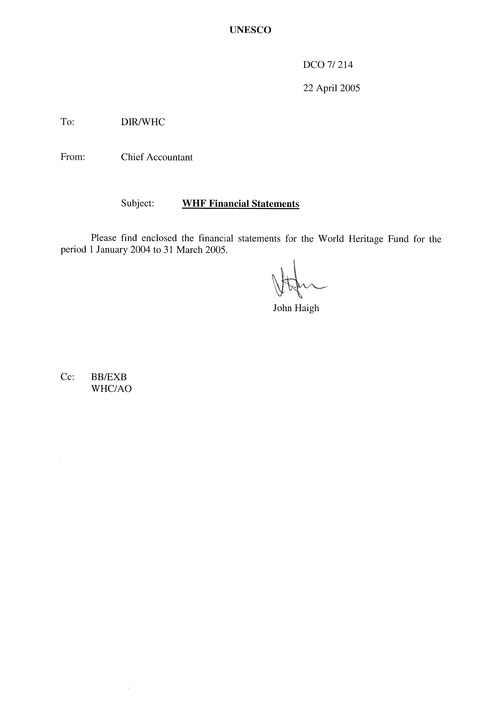
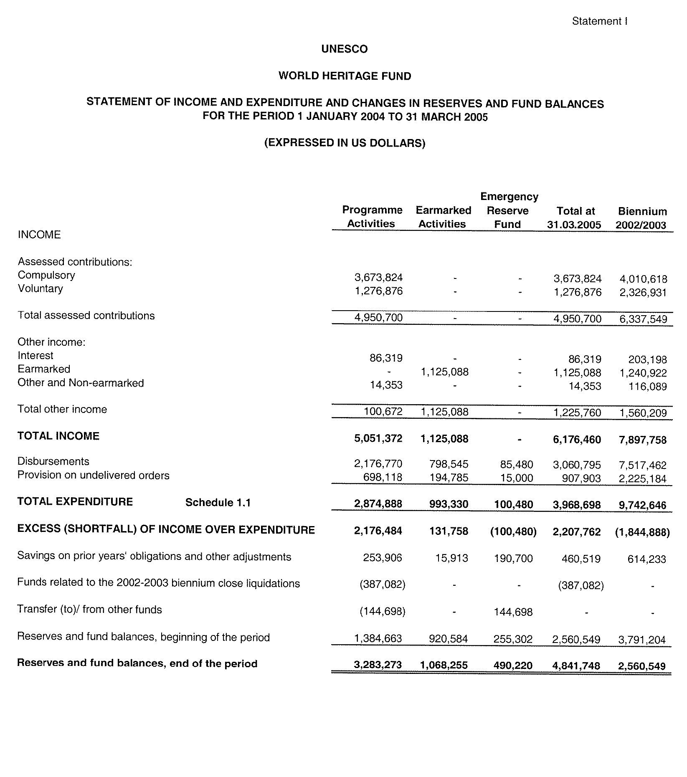
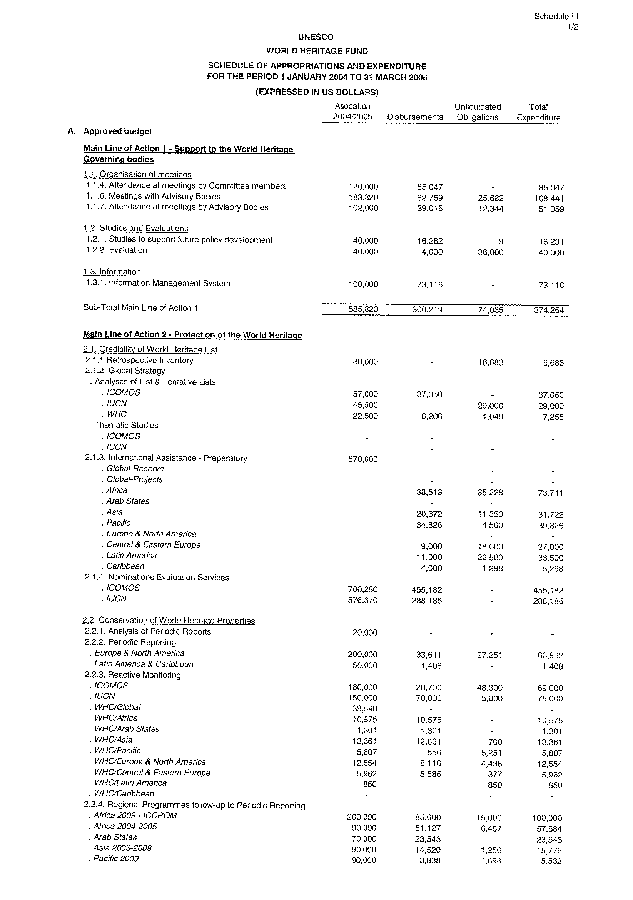
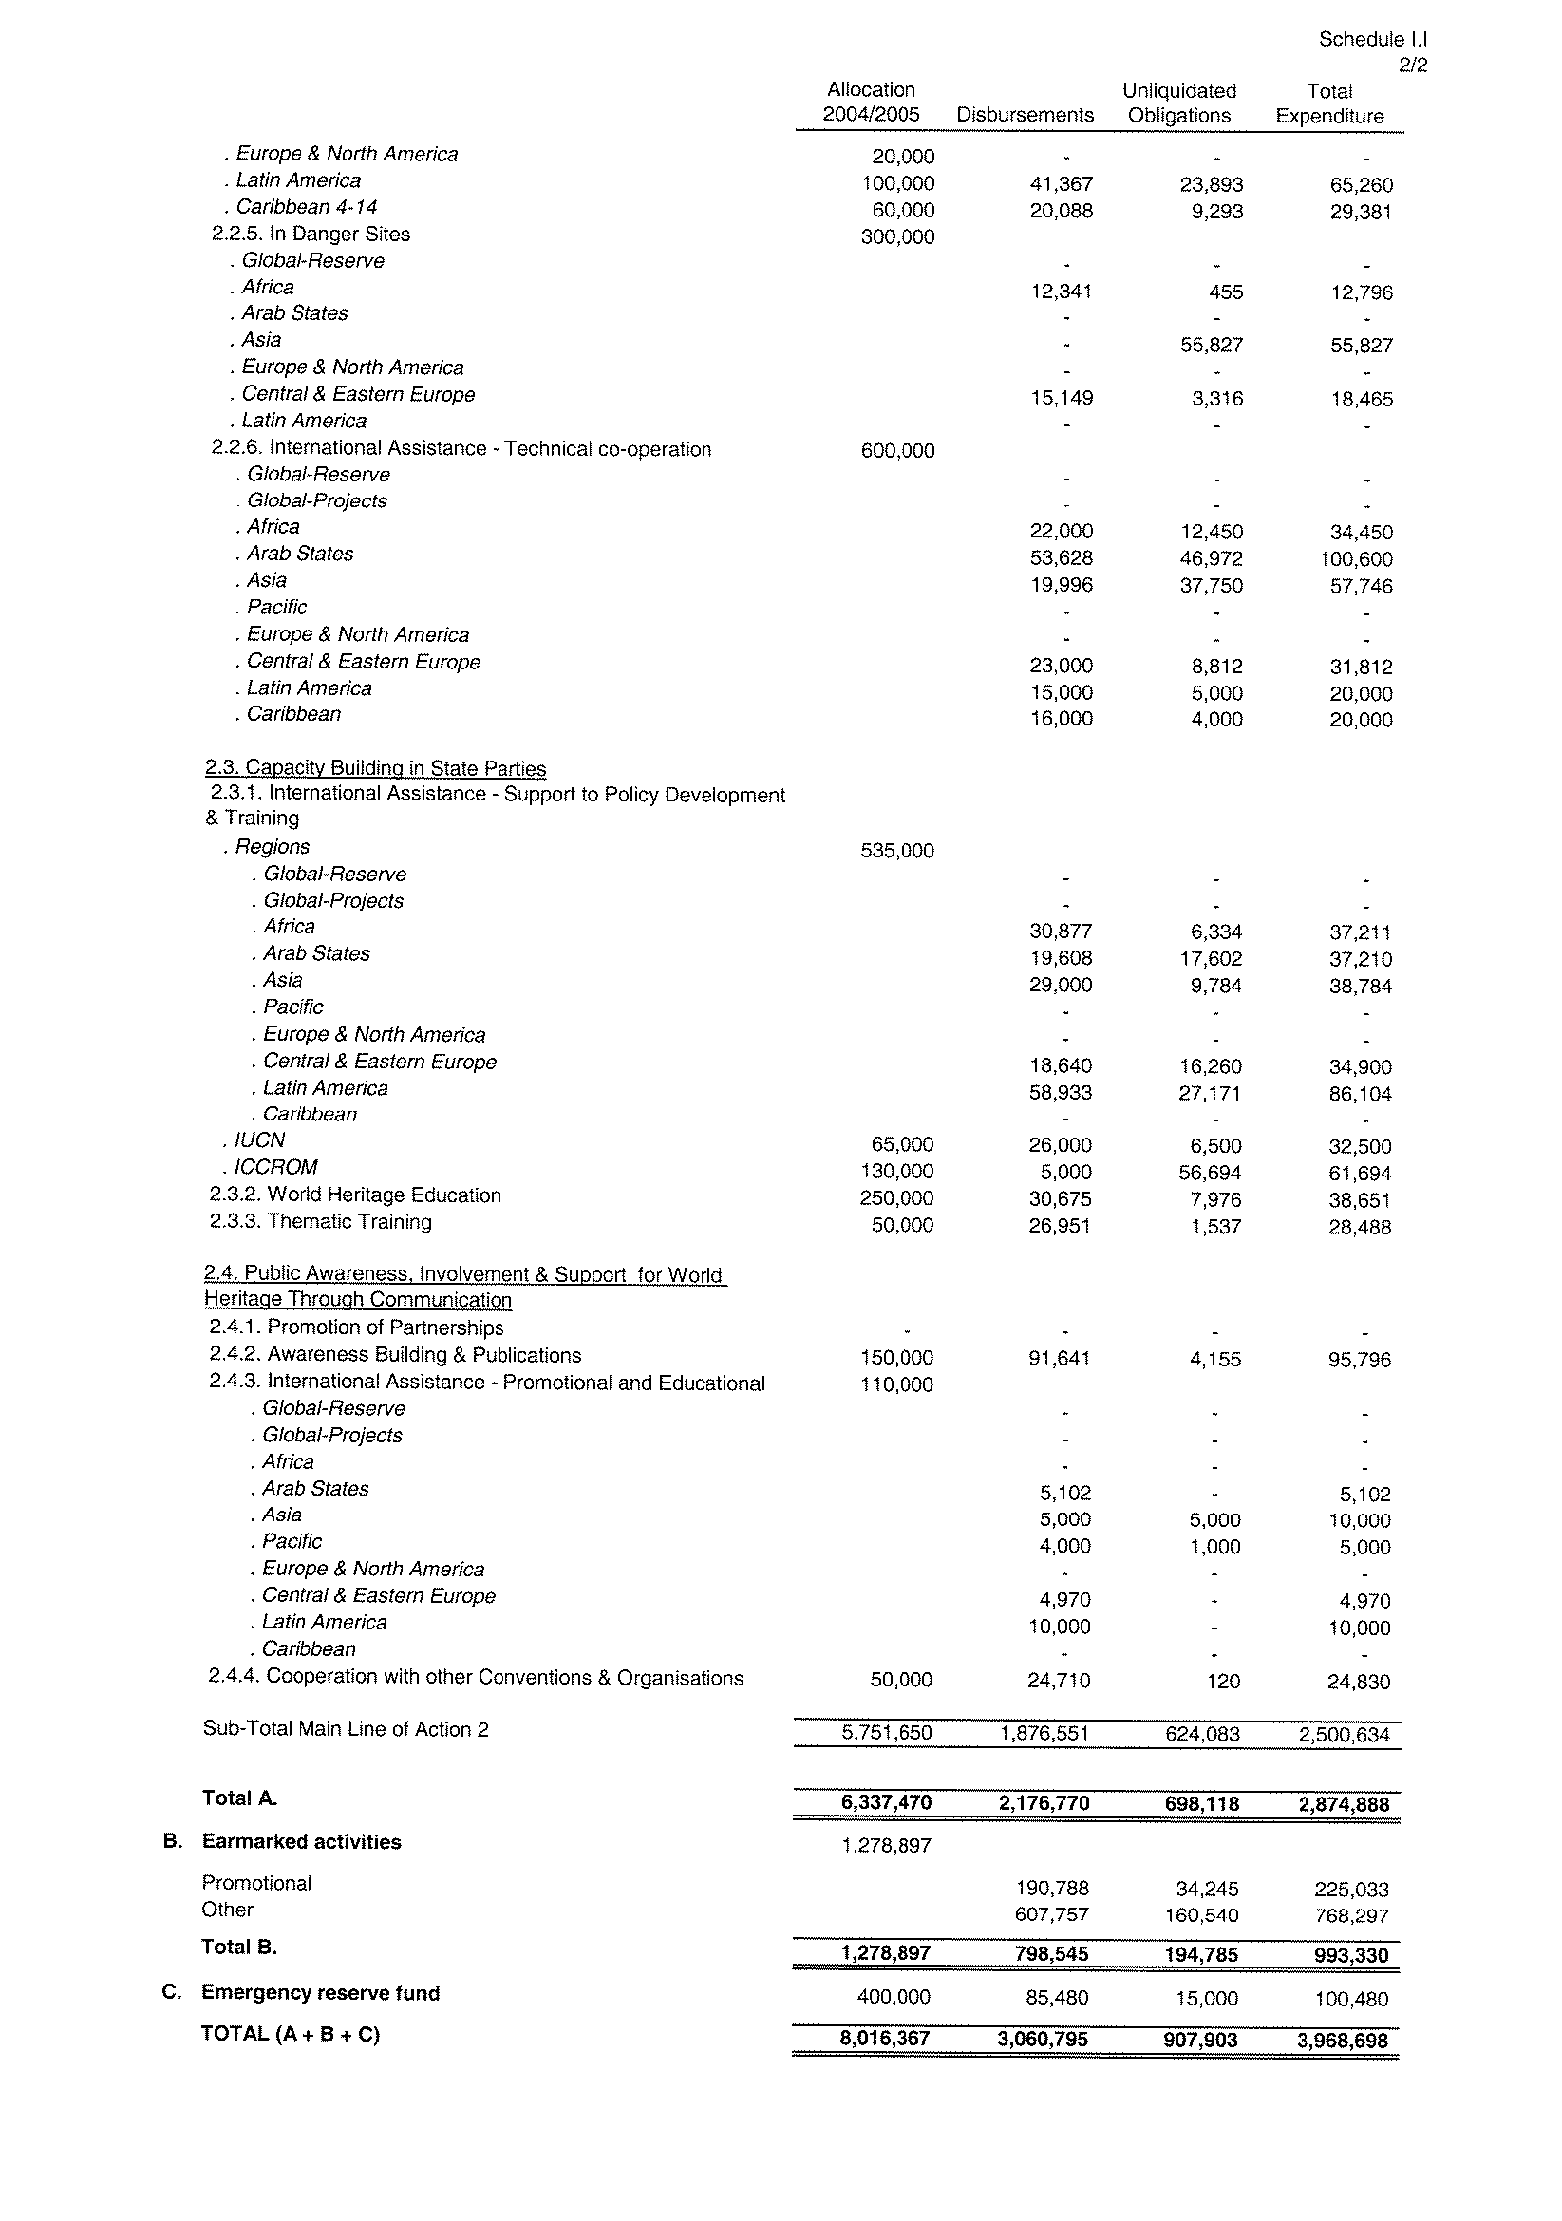
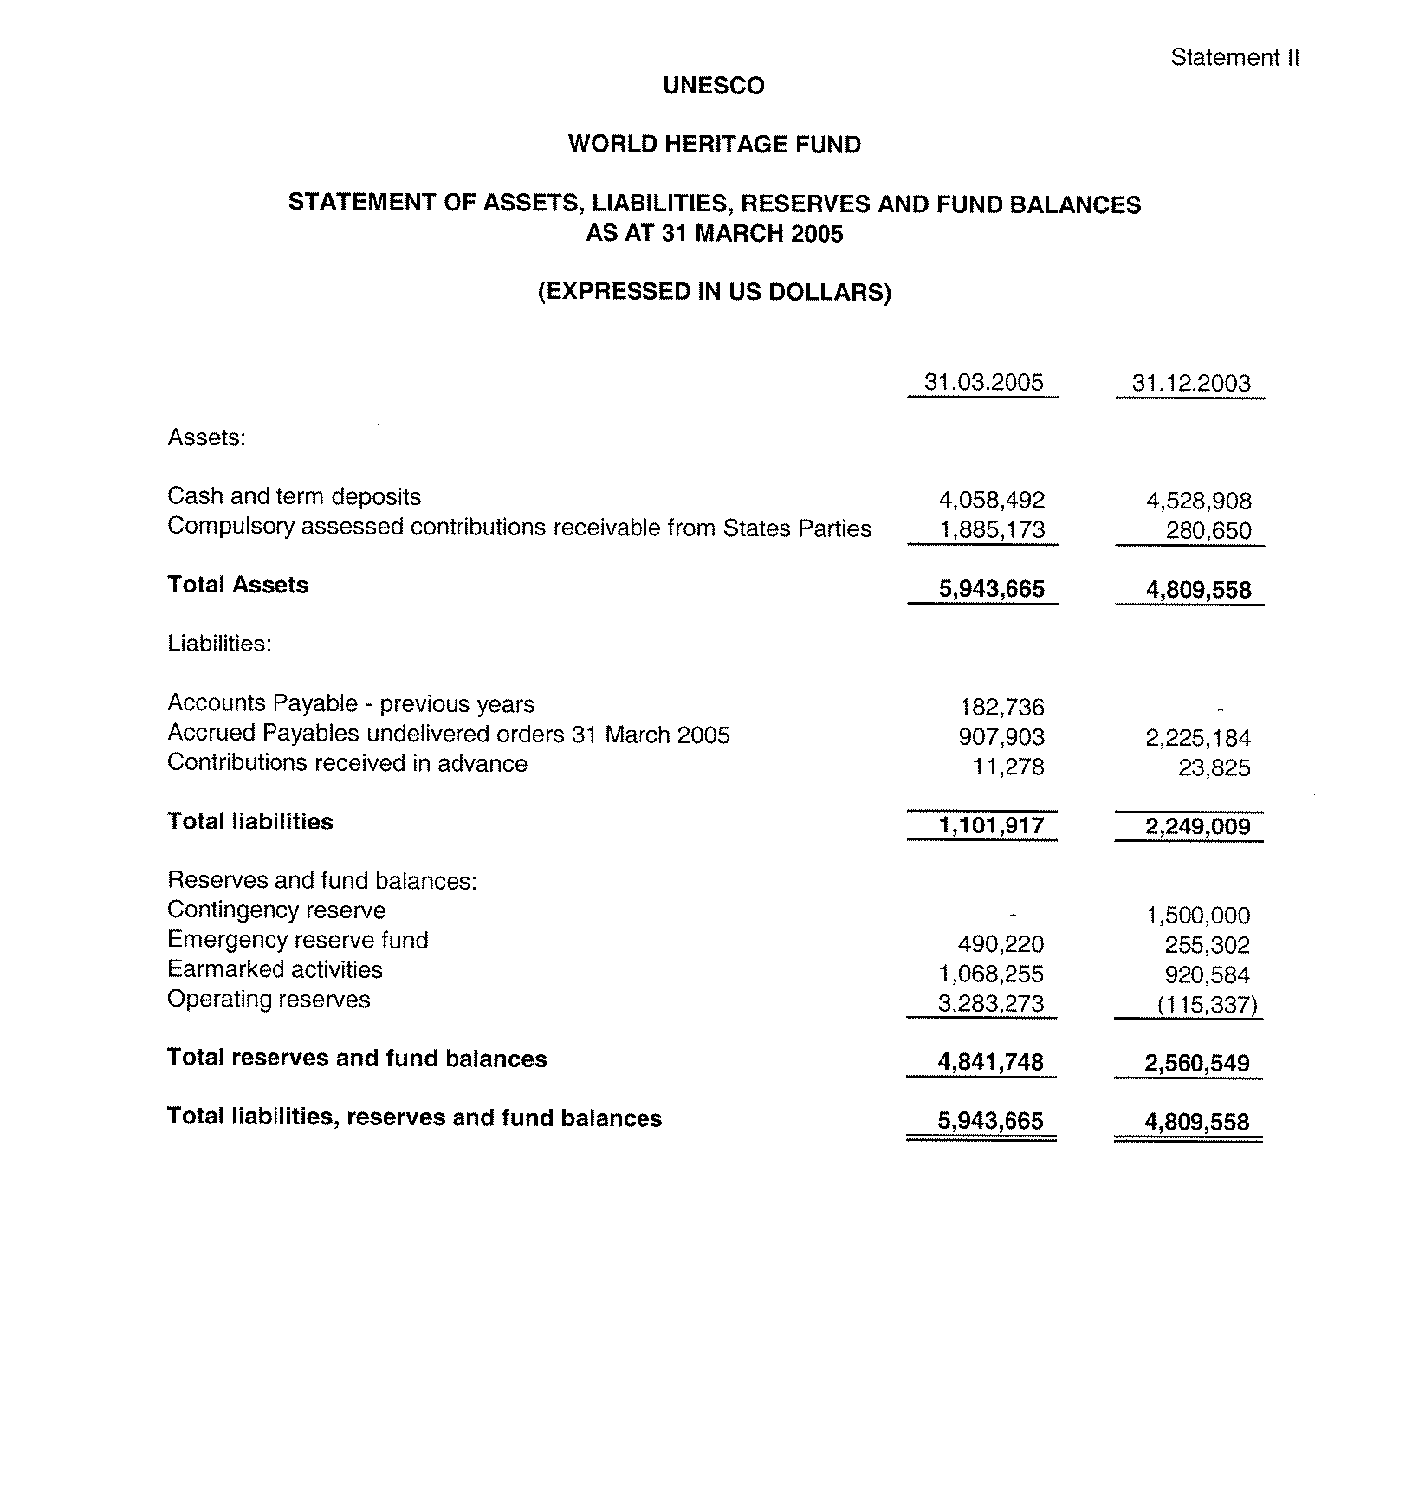
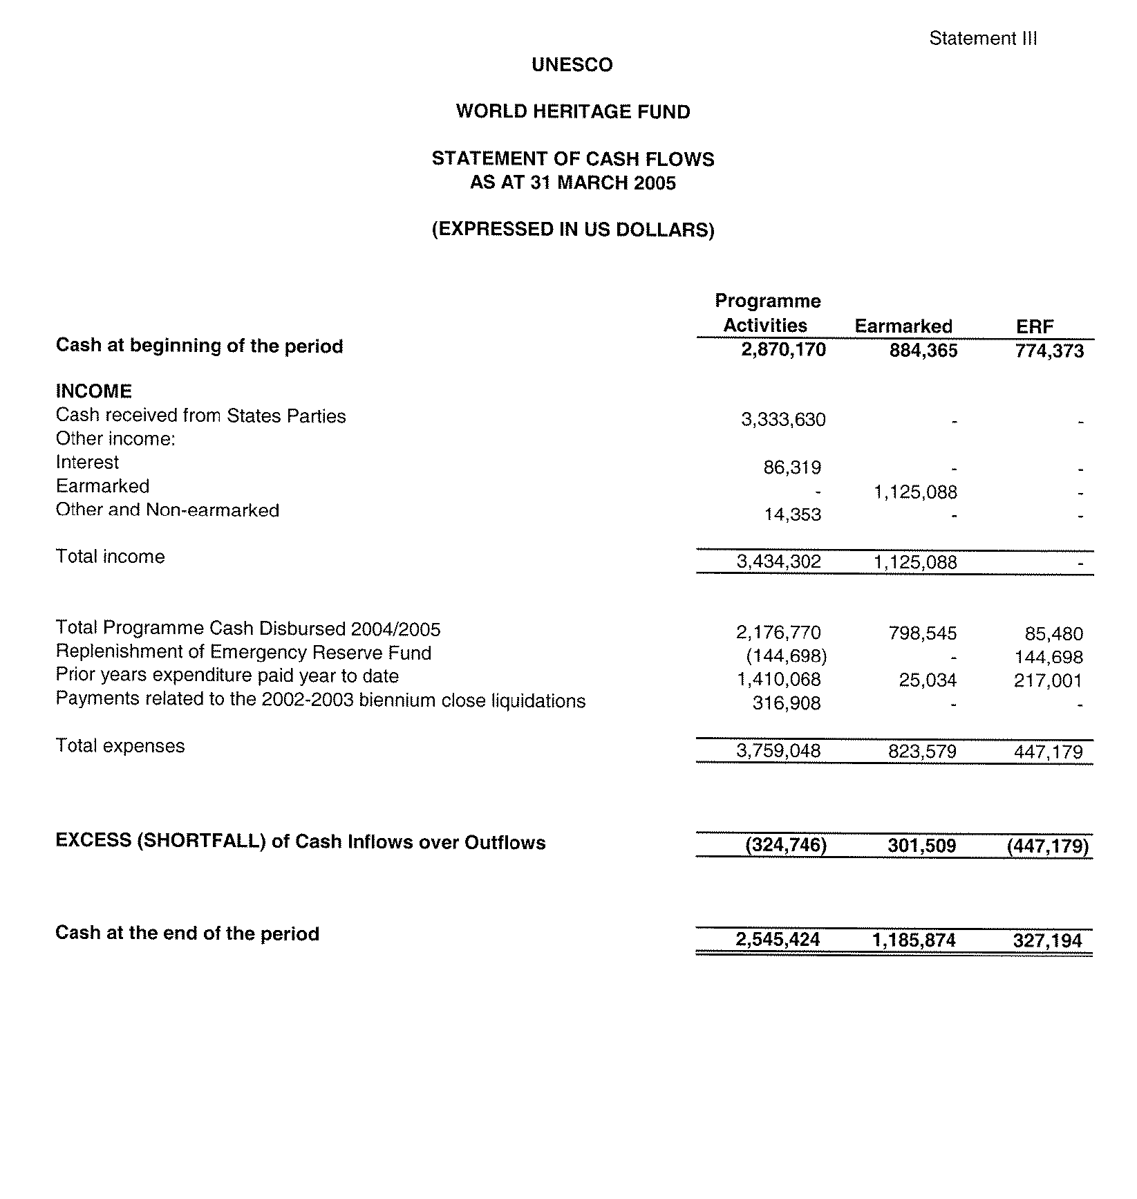
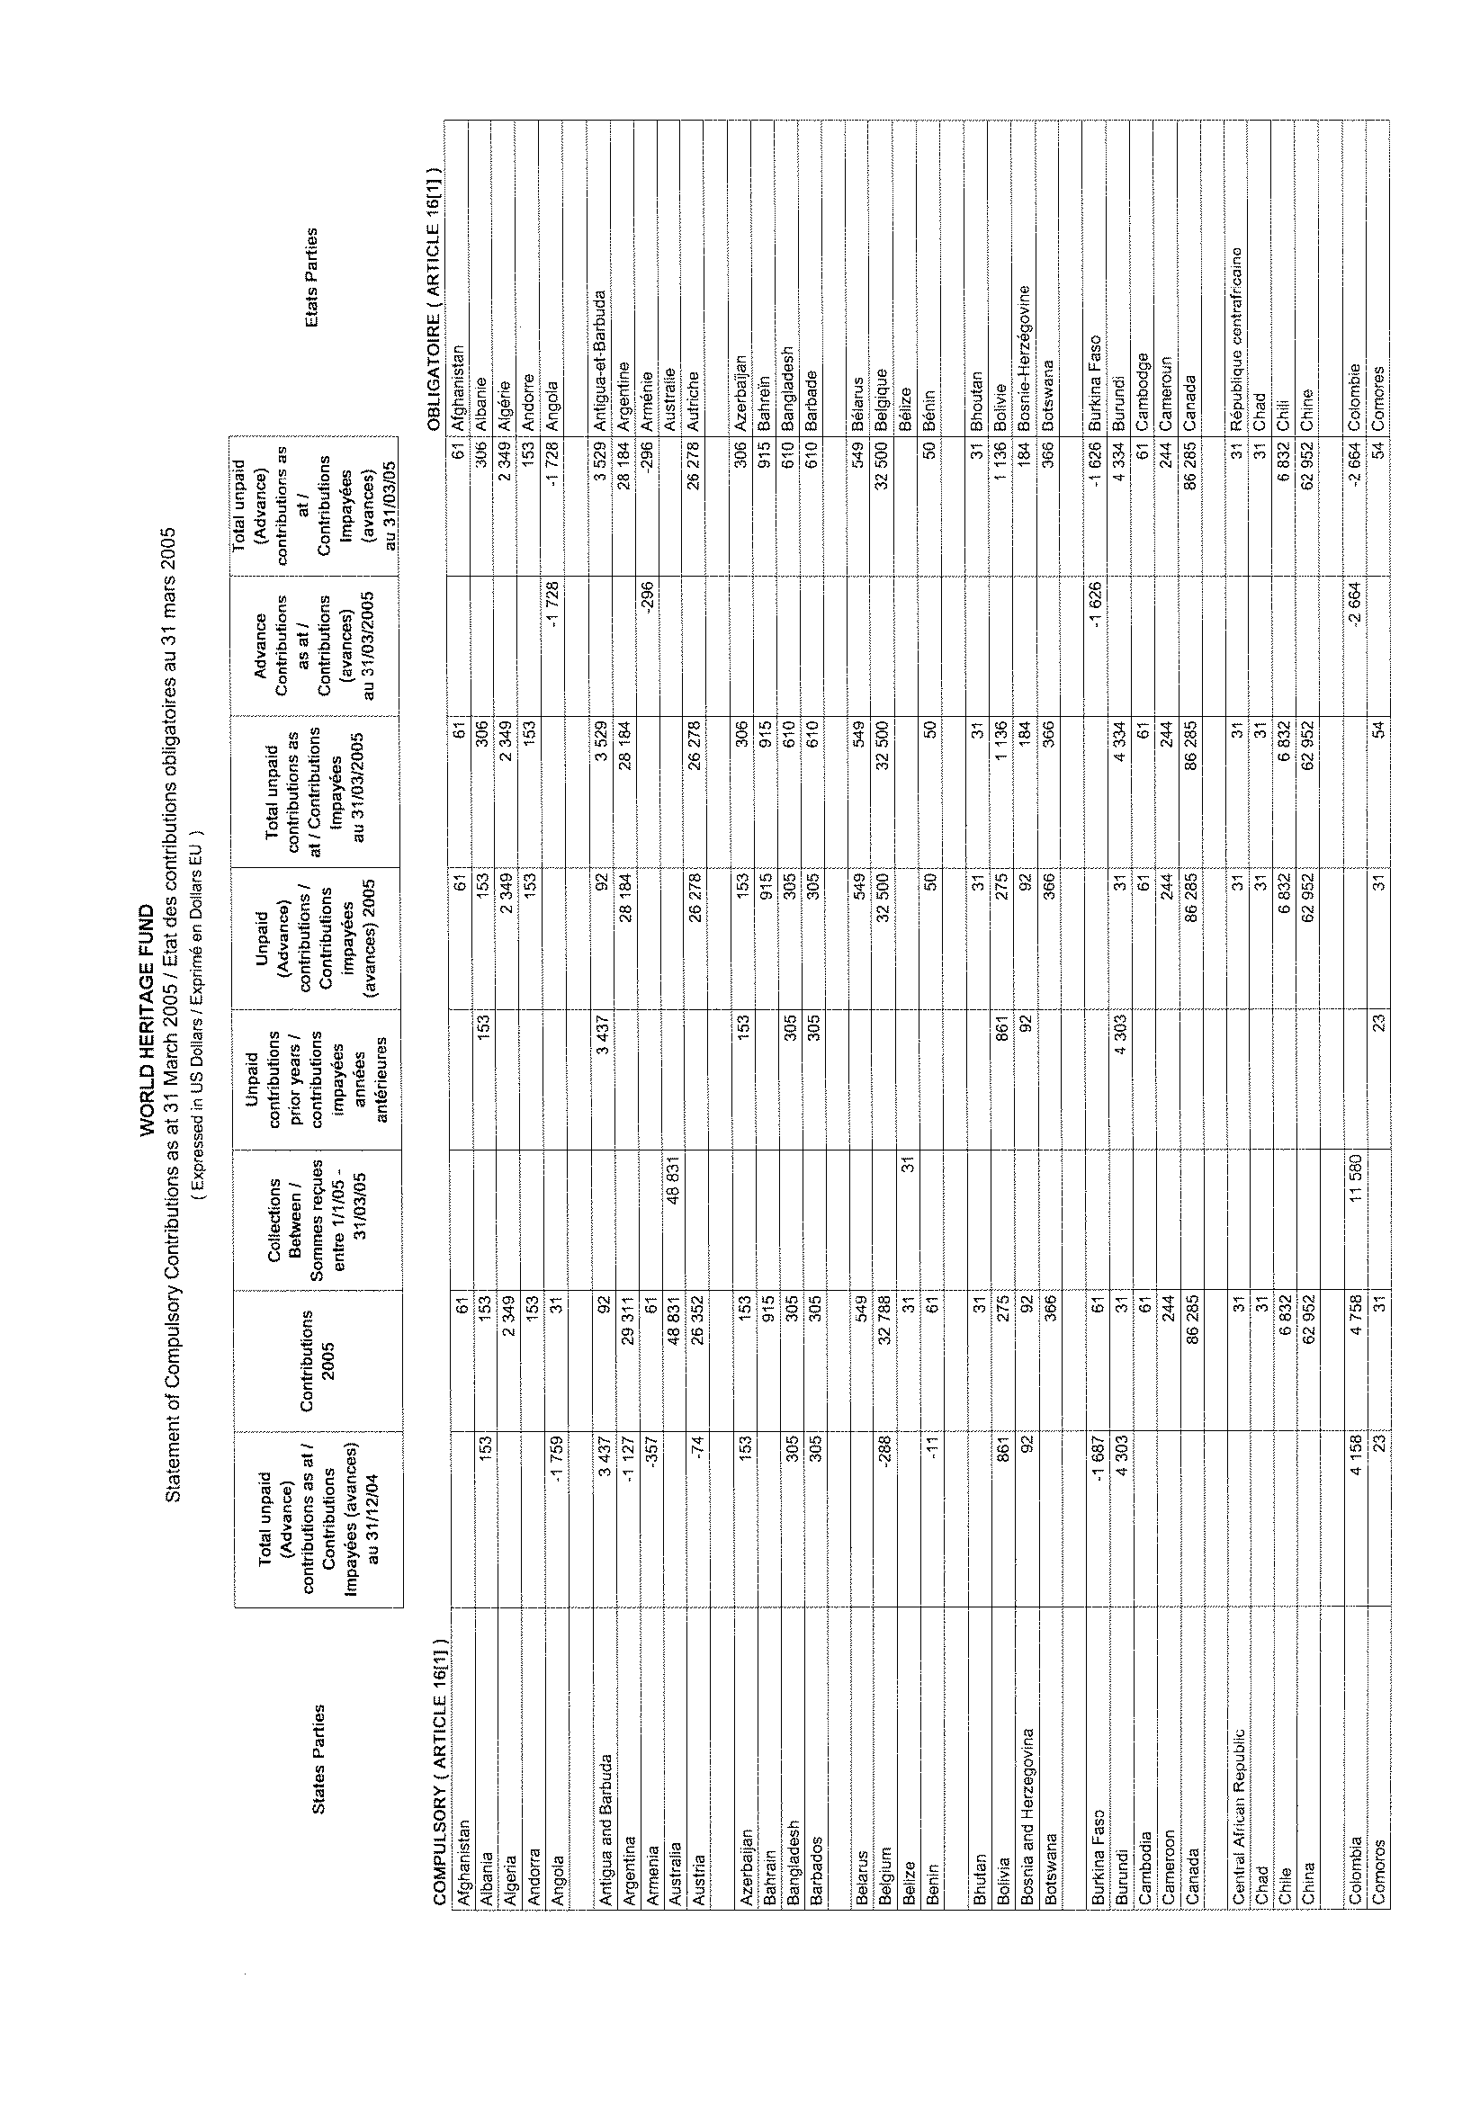
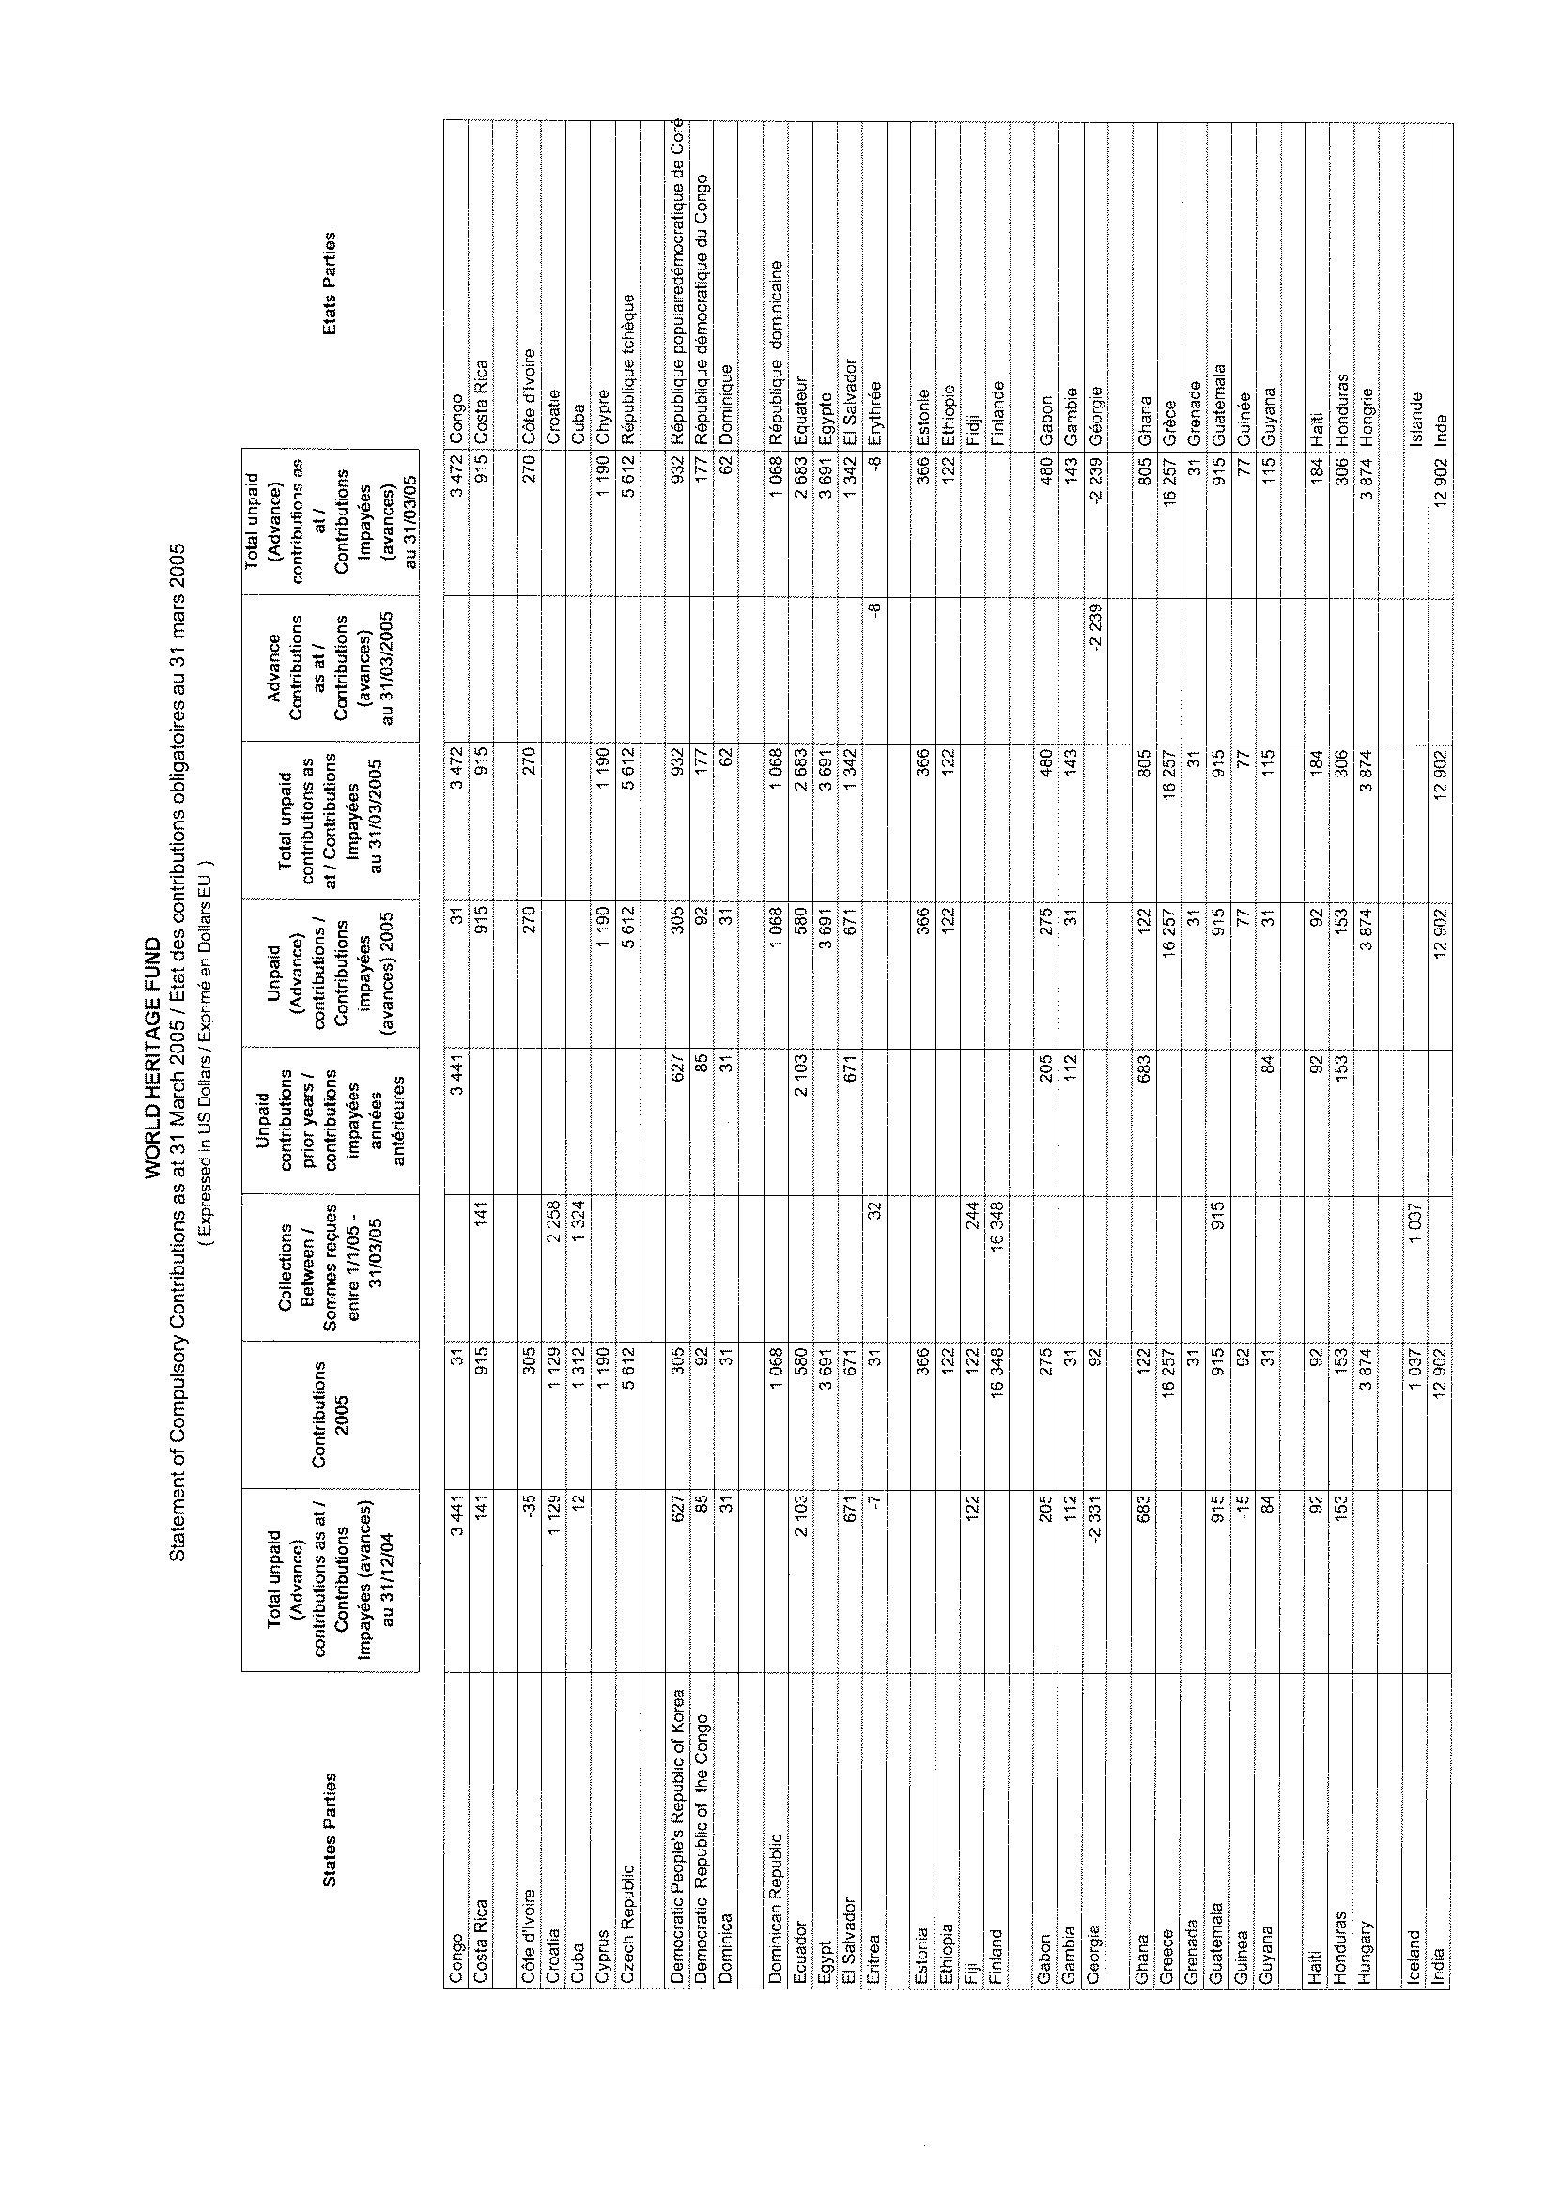
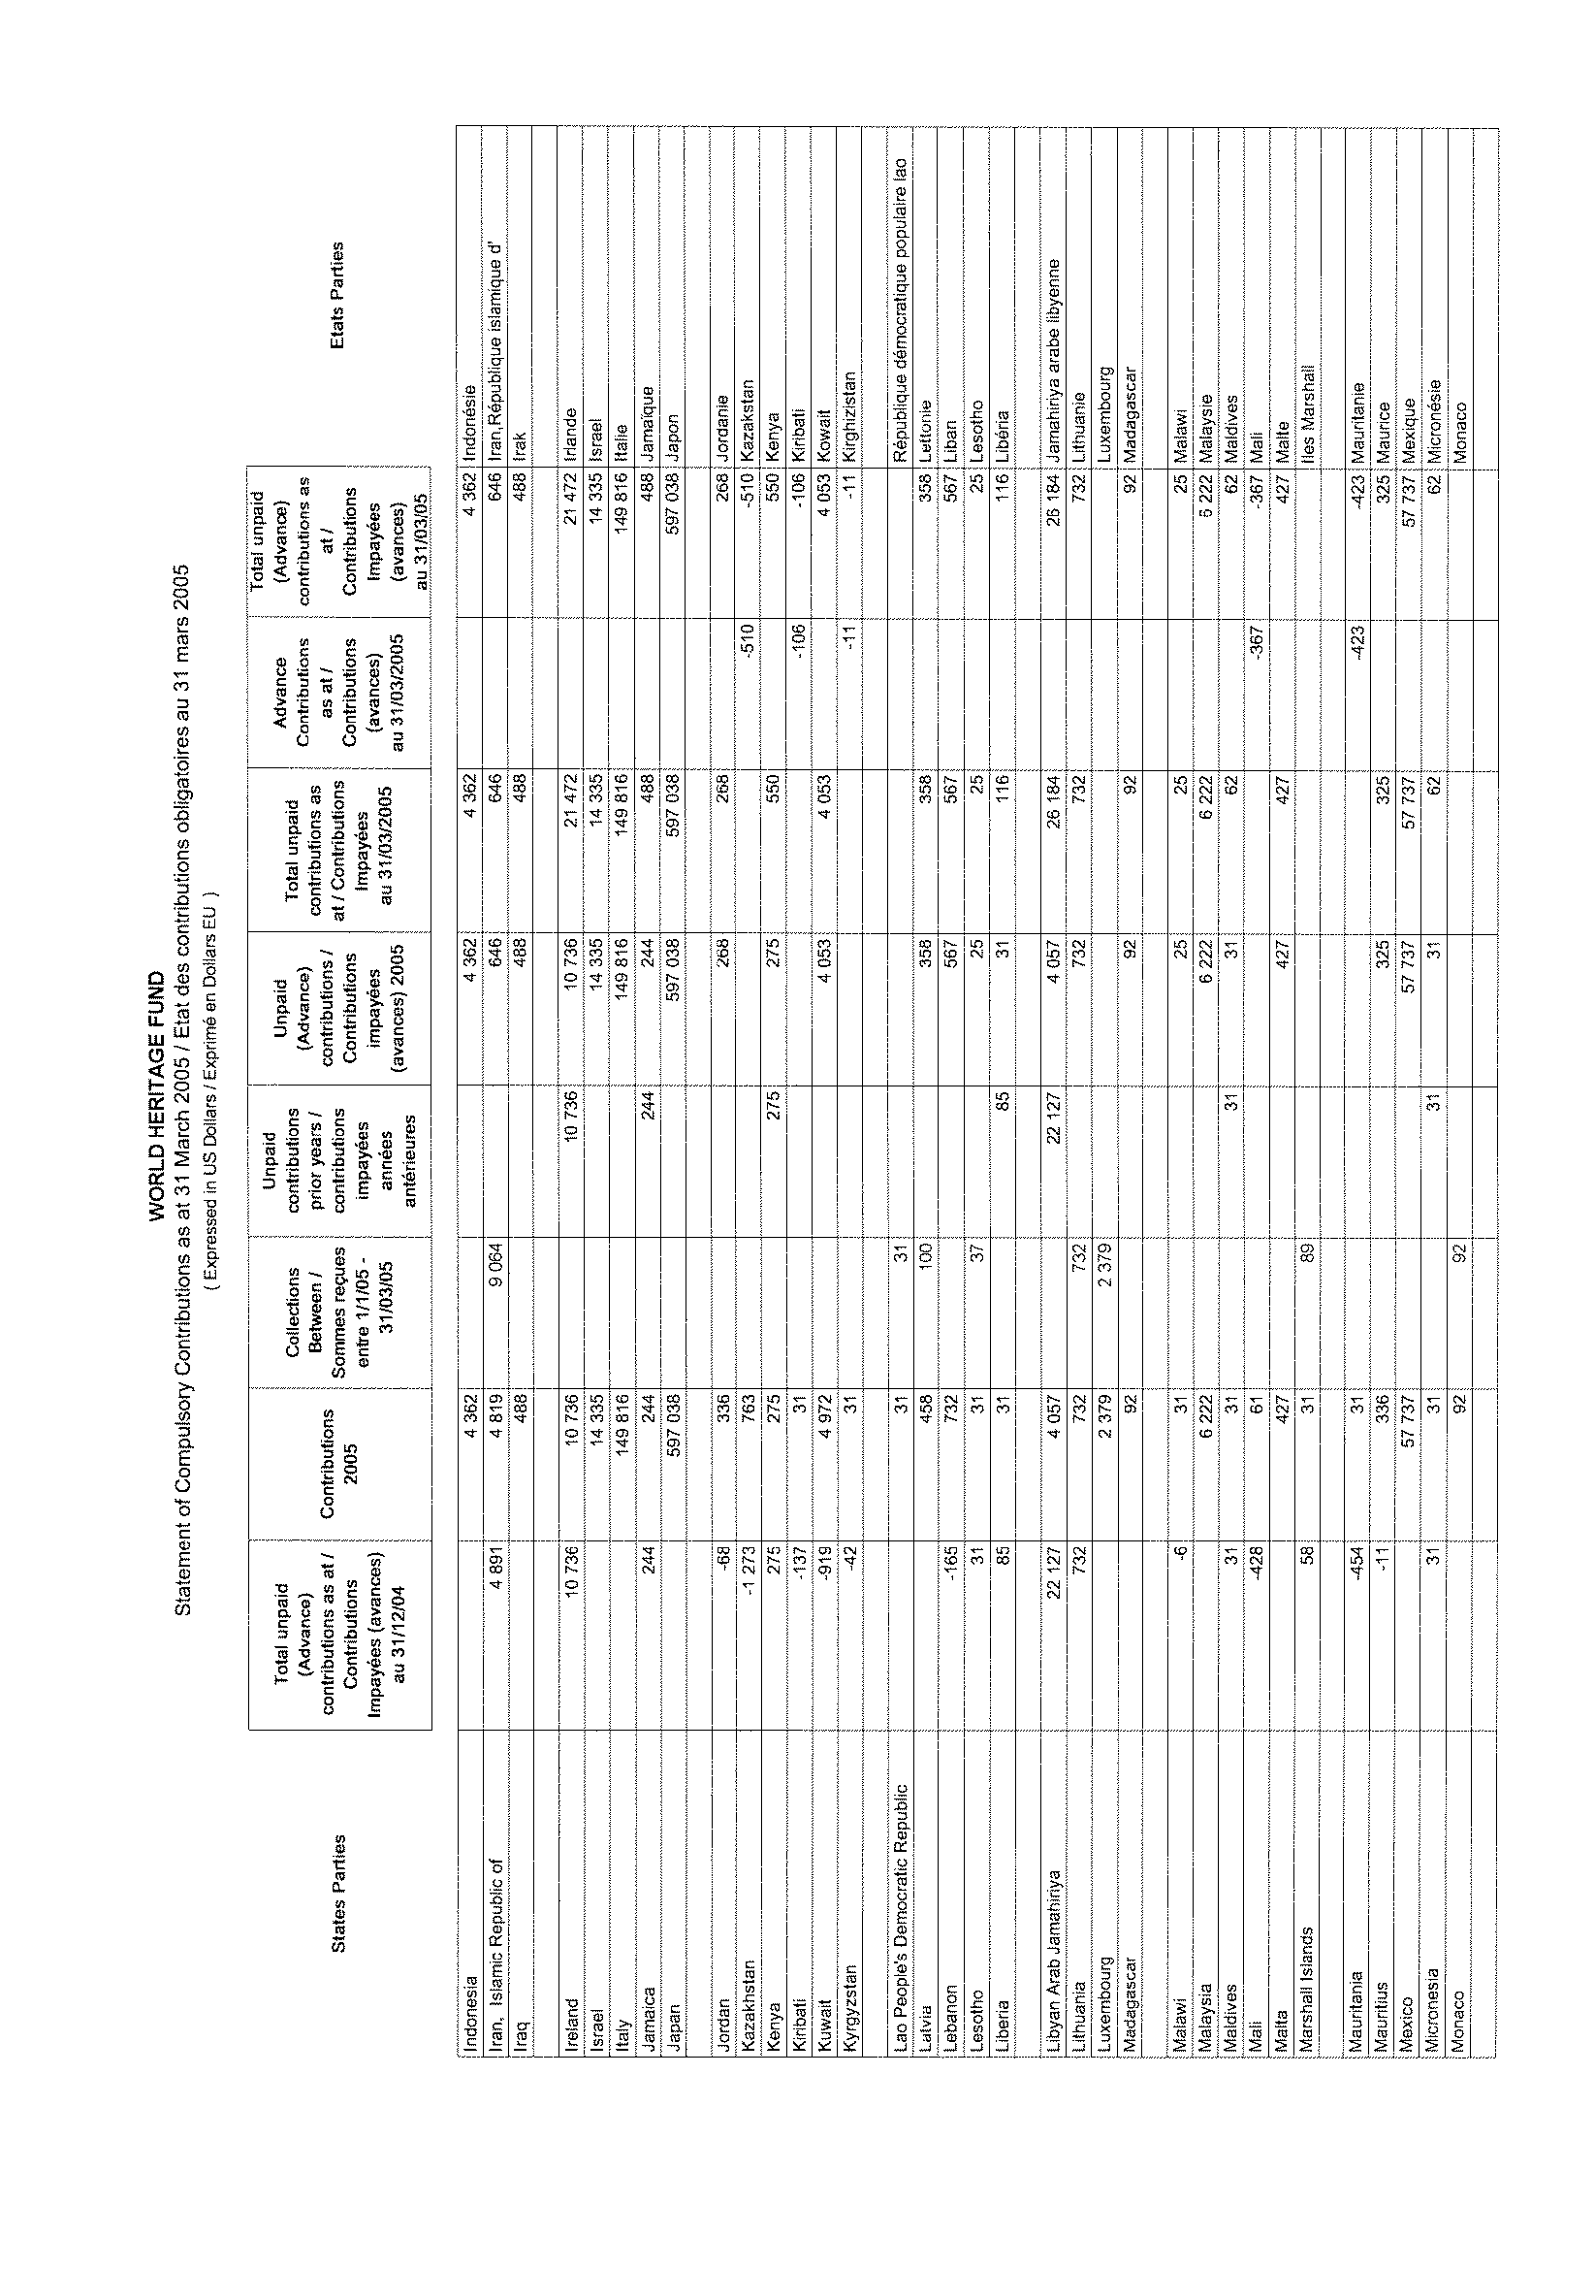
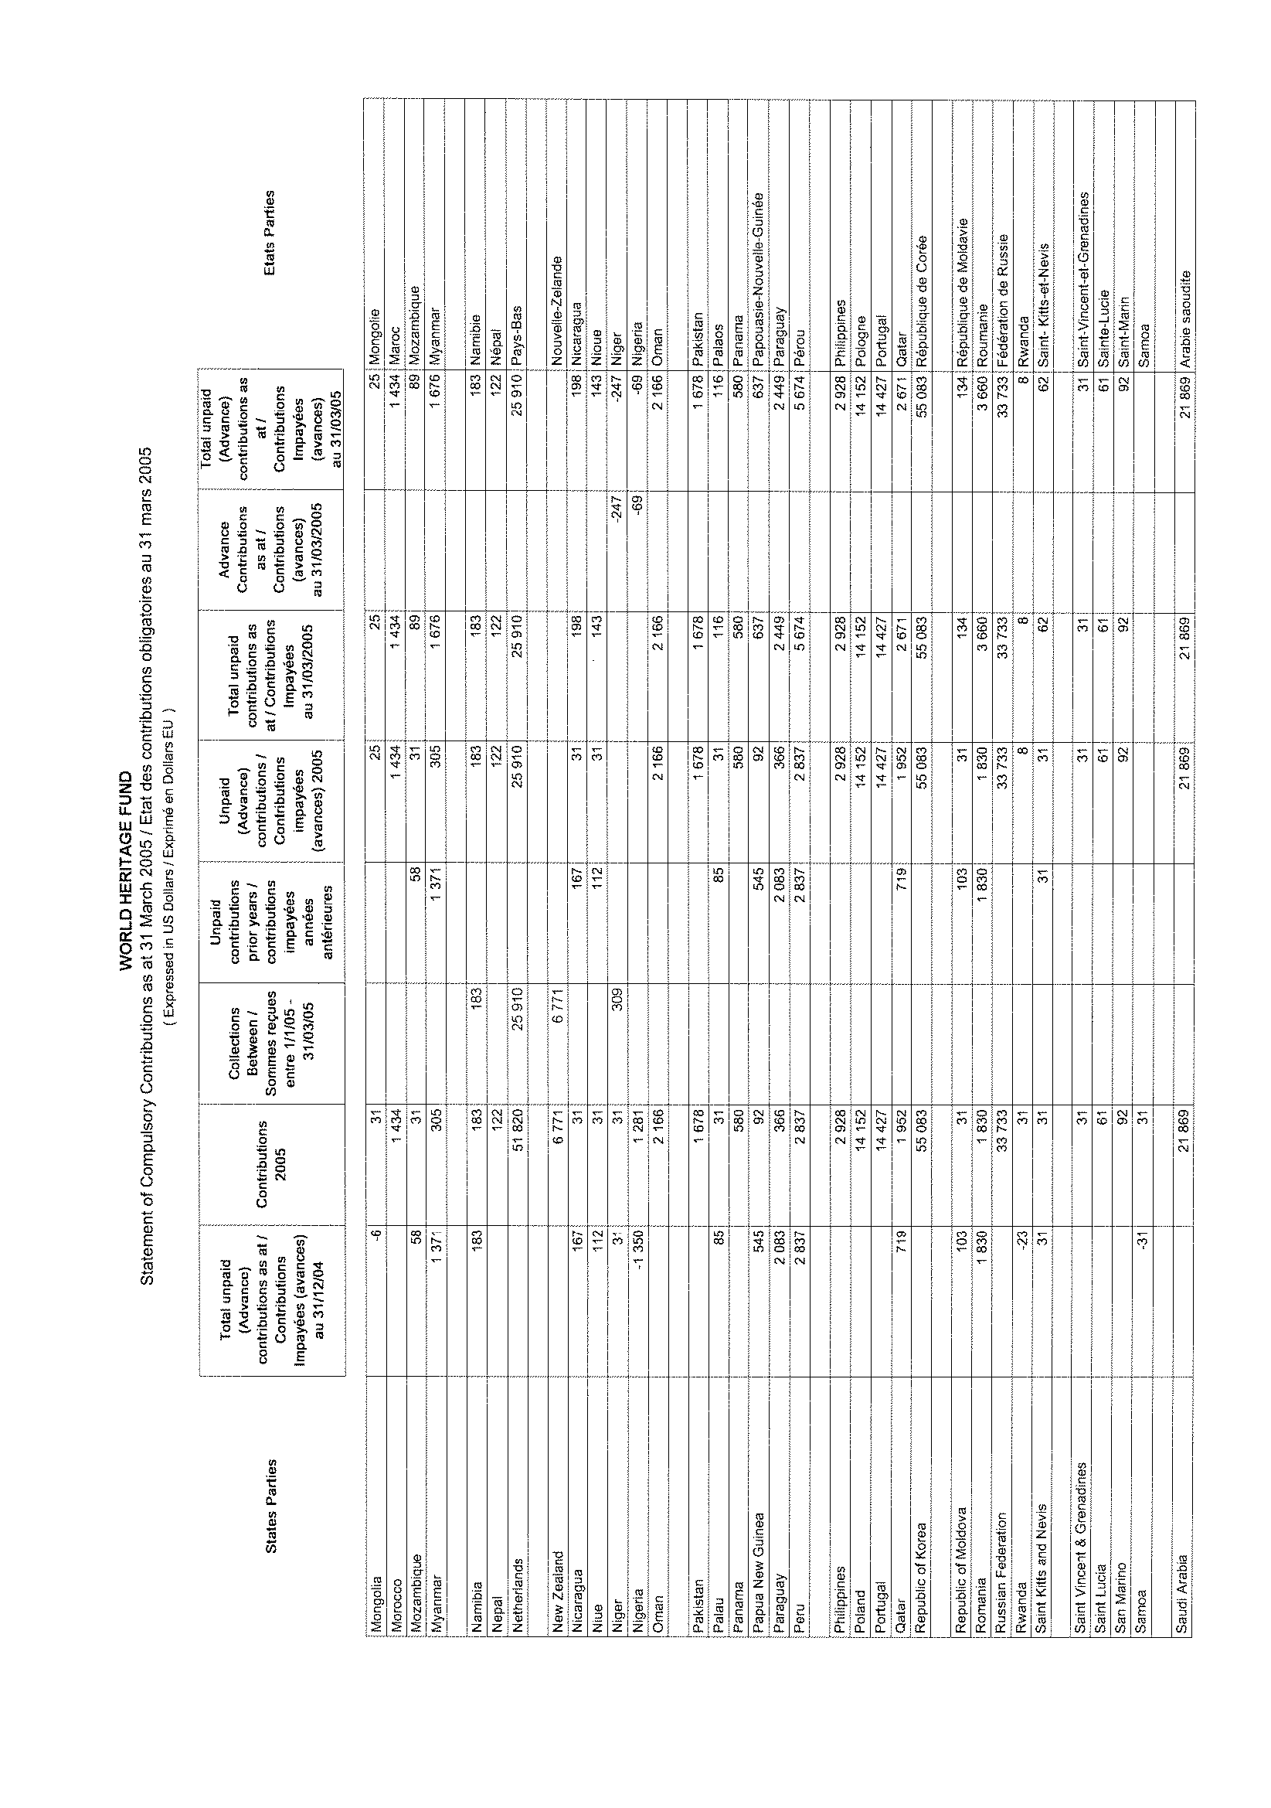
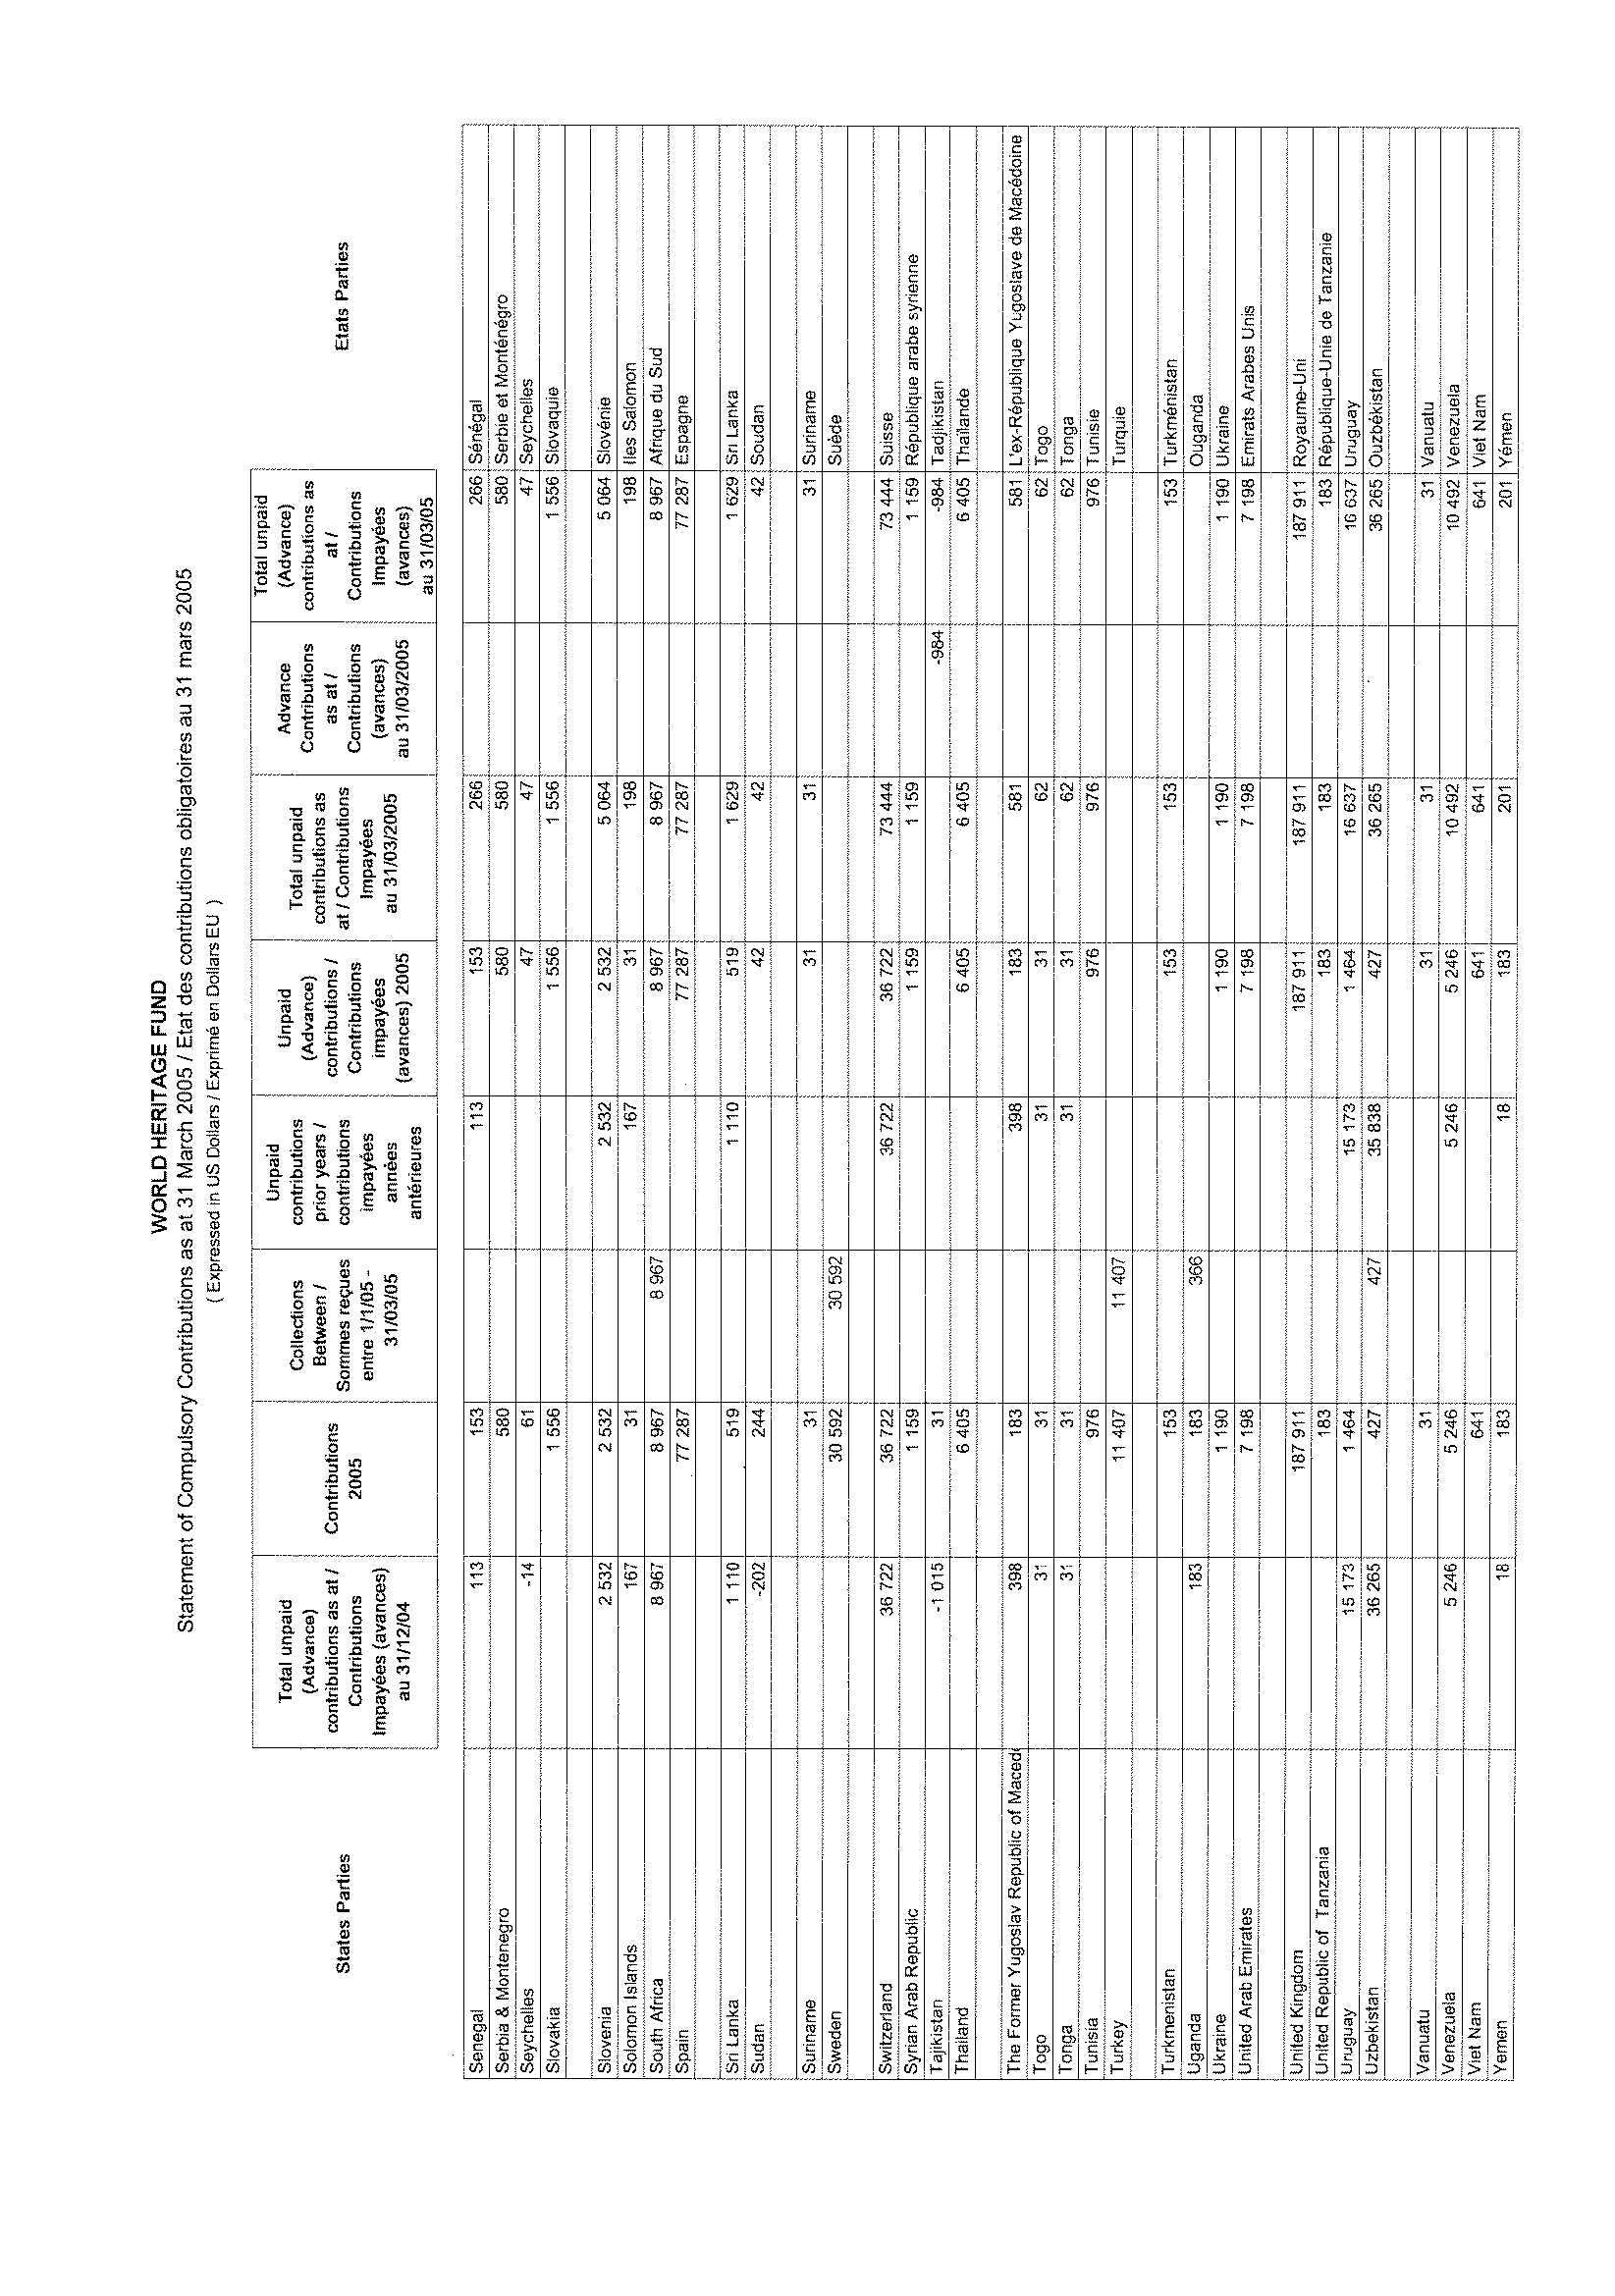
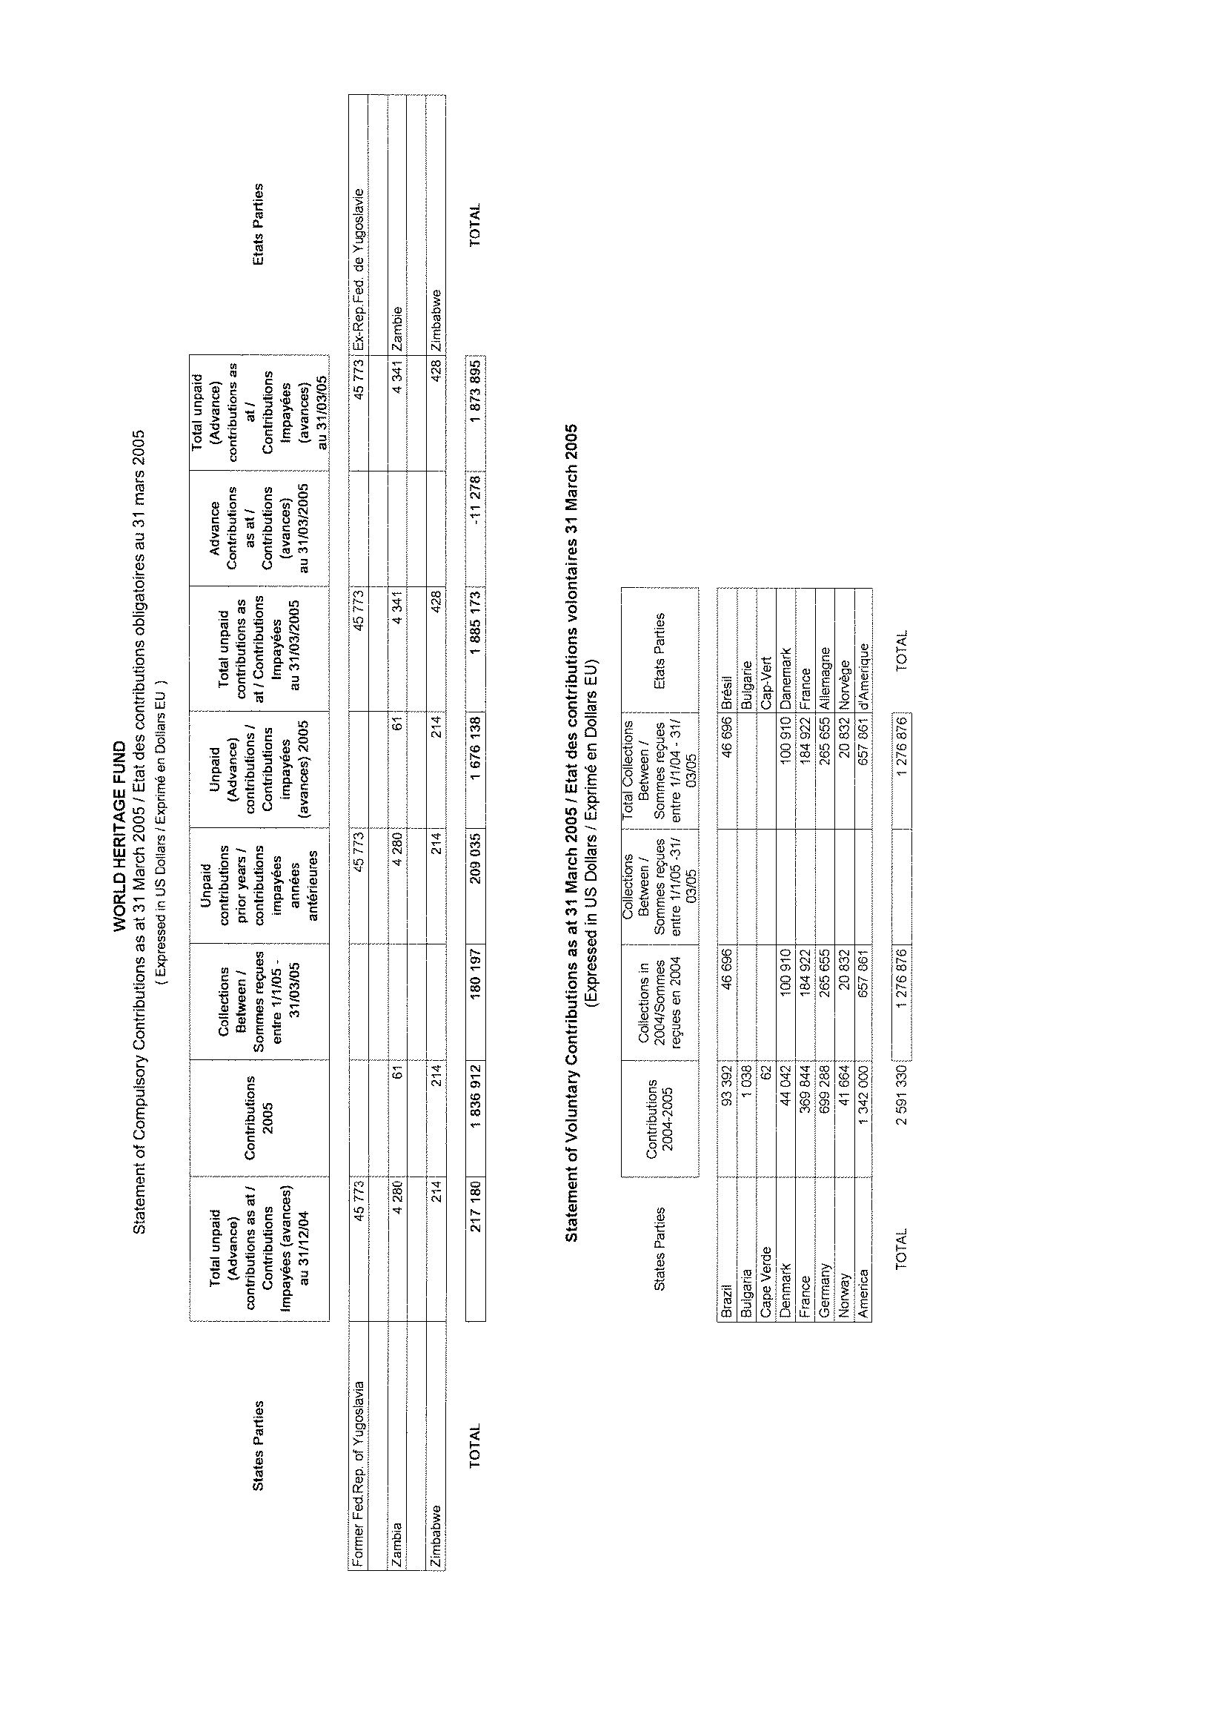

ANNEX III

Extra budgetary projects affected to World Heritage
and managed by other Divisions or Sectors

2004-2005
INFORMATION DOCUMENT ON EXTRA-BUDGETARY RESOURCES FOR WORLD HERITAGE SITES IMPLEMENTED BY CLT/CH (Division of Cultural Heritage)
DURING 2004-2005

DOCUMENT D'INFORMATION: PROJETS CONCERNANT LE PATRIMOINE MONDIAL ET MIS EN OEUVRE PAR CLT/CH (Division du Patrimoine Culturel)
AU COURS DE 2004-2005

REGION: AFRICA / AFRIQUE

Country - World Heritage Site / Pays – Site du patrimoine medial | Project title / Titre du projet | “Donor” / “Donateur” | HQ Division or Field Office / Division du Siège ou Bureau régional | Total approved budget in US$/ Budget total approuvé en dollars EU

Benin / Bénin
Royal Palaces of Abomey / Palais royaux d’Abomey | Rehabilitation of the Royal Palace of Abomey / Réhabilitation du palais royal d’Abomey | Japan / Japon | CLT-CH | 416,932
Senegal /Sénégal
Island of Gorée / Ile de Gorée | International Campaign for the Safeguarding of the Island of Gorée / Campagne internationale de sauvegarde de l’île de Gorée | International Campaign voluntary contributions / Contributions volontaires issues d’une campagne internationale | CLT-CH | 132,570

INFORMATION DOCUMENT ON EXTRA-BUDGETARY RESOURCES FOR WORLD HERITAGE SITES IMPLEMENTED BY CLT/CH (Division of Cultural Heritage)
DURING 2004-2005

DOCUMENT D'INFORMATION: PROJETS CONCERNANT LE PATRIMOINE MONDIAL ET MIS EN OEUVRE PAR CLT/CH (Division du Patrimoine Culturel)
AU COURS DE 2004-2005

REGION: EUROPE

Country - World Heritage Site / Pays – Site du patrimoine mondial | Project title / Titre du projet | “Donor” / “Donateur” | HQ Division or Field Office / Division du Siège ou Bureau régional | Total approved budget in US$/ Budget total approuvé en dollars EU
Malta / Malte
Historic Malta / Malte historique | Campaign for the safeguarding of Historic Malta / Campagne de sauvegarde de Malte historique | International Campaign voluntary contributions / Contributions volontaires issues d’une campagne internationale | CLT-CH | 95,088
Turkey / Turquie
Historic areas of Istanbul / Zones historiques d’Istanbul  Göreme National Park and the Rock Sites of Cappadocia / Parc Nacional de Göreme et sites rupestres de Cappadoce | International Campaign for the Safeguarding of the Historic Quarters of Istanbul and the Site of Göreme in Cappadocia / Campagne internationale de sauvegarde des quartiers historiques d’Istanbul, et du site de Göreme en Cappadoce | International Campaign voluntary contributions / Contributions volontaires issues d’une campagne internationale | CLT-CH | 206,683
INFORMATION DOCUMENT ON EXTRA-BUDGETARY RESOURCES FOR WORLD HERITAGE SITES IMPLEMENTED BY CLT/CH (Division of Cultural Heritage)
DURING 2004-2005

DOCUMENT D'INFORMATION: PROJETS CONCERNANT LE PATRIMOINE MONDIAL ET MIS EN OEUVRE PAR CLT/CH (Division du Patrimoine Culturel)
AU COURS DE 2004-2005

REGION: ASIA - PACIFIC / ASIE - PACIFIQUE

Country - World Heritage Site / Pays – Site du patrimoine mondial | Project title / Titre du projet | “Donor” / “Donateur” | HQ Division or Field Office / Division du Siège ou Bureau régional | Total approved budget in US$/ Budget total approuvé en dollars EU
Afghanistan / Afghanistan
Bamiyan / Bamiyan | Safeguarding of the Bamiyan site / Sauvegarde du site de Bamyian | Japan / Japon | CLT-CH | 1,815,967
 | Safeguarding of Cultural Heritage Phase II / Sauvegarde du patrimoine culturel, phase II | Italy / Italie | CLT-CH | 169.500
Bangladesh / Bangladesh
City of Bagerhat  and Paharpur / Ville de Bagerhat et Paharpur | Special Account for Safeguarding Historic Paharpur and Bagerhat / Compte spécial pour Paharpur historique et Bagerhat | International Campaign voluntary contributions / Contributions volontaires issues d’une campagne internationale | CLT-CH | 13,171
Cambodia / Cambodge
Angkor / Angkor | Exploratory Mission for the preparation of a third phase of an operational project in the temple of Bayon / Mission exploratoire pour la préparation de la troisième phase d’un projet opérationnel au temple de Bayon | Japan / Japon | CLT-CH | 12,779
Angkor / Angkor | Training of tourists guide in Cambodia / Formation des Guides touristiques au Cambodge | American Express / American Express | CLT-CH | 50,000
Country - World Heritage Site / Pays – Site du patrimoine mondial | Project title / Titre du projet | “Donor” / “Donateur” | HQ Division or Field Office / Division du Siège ou Bureau régional | Total approved budget in US$/ Budget total approuvé en dollars EU
Angkor / Angkor | International Conference Angkor Site / Conférence internationale sur le site d’Angkor | Japan / Japon | CLT-CH | 19,283
Angkor / Angkor | CD-ROM on Preservation of Bayon Temple / CD-Rom sur la conservation du temple de Bayon | Japan / Japon | CLT-CH | 48,195
Angkor / Angkor | Support to Meetings of the International Coordination Committee for Angkor / Soutien aux réunions du Comité International pour Angkor | Japan / Japon | Phnom Penh Office / Bureau de Phnom Penh | 24,634
Angkor / Angkor | Documentary Film / Film documentaire | Japan / Japon | CLT-CH | 24,860
Angkor / Angkor | International Seminar Angkor and Water / Colloque International: Angkor et Eau | France / France | CLT-CH | 28,300
Angkor / Angkor | Selection of Inscriptions on Cambodia in Publication of Epigraphic Reference Book / Sélection d’inscriptions sur le Cambdoge et publication d’un livre de référence épigraphique | Japan / Japon | CLT-CH | 79,100
Angkor / Angkor | Production of International Versions of a Series of Video Films / Production de versions internationales de séries de vidéo films | Japan / Japon | CLT-CH | 16,183
Royal Plaza of Angkor Thom and Angkor Wat / Place royale d’Angkor Thom et Angkor Vat | Conservation and Restoration of the Royal and Angkor Wat - Phase II / Conservation et restauration d’Angkor royal et d’Angkor Vat | Japan / Japon | CLT-CH | 10,996,400
China / Chine
Peking Man Site at Zhoukoudian / L’homme de Pékin à Zhoukoudian | Rehabilitation, Protection and Conservation of the Peking Man World Heritage Site / Réhabilitation, protection et conservation du site du patrimoine mondial de l’homme de Pékin | Private funds / Fonds privés | CLT-CH | 2,500,000
Country - World Heritage Site / Pays – Site du patrimoine mondial | Project title / Titre du projet | “Donor” / “Donateur” | HQ Division or Field Office / Division du Siège ou Bureau régional | Total approved budget in US$/ Budget total approuvé en dollars EU

India / Inde
Buddhist Monuments at Sanchi & Satdhara / Monuments bouddhiques à Sanchi et Satdhara | Expert evaluation mission on conservation and preservation of the Buddist monuments in Sanchi and Satdhara / Mission d’évaluation d’experts sur la conservation et la préservation des monuments bouddhiques de Sanchi et Satdhara | Japan / Japon | CLT-CH | 25,398
Buddhist Monuments at Sanchi & Satdhara / Monuments bouddhiques à Sanchi et Satdhara | Conservation and preservation of the Buddist monuments in Sanchi and Satdhara / Conservation et préservation des monuments bouddhiques de Sanchi et Satdhara | Japan / Japon | CLT-CH | 500,038
Taj Mahal / Taj Mahal | Preservation of the Taj Mahal and Other Monuments in Agra / Préservation du Taj Mahal et d’autres monuments à Agra | Private funds / Fonds privés | CLT-CH | 158,200

Iran / Iran
Tchogha Zanbil / Tchoga Zanbil | Conservation of Tchogha Zanbil / Conservation de Tchoga Zanbil | Japan / Japon | Tehran office | 442,000
Kazakhstan / Kazakhstan
Tamgaly / Tamgaly | Tamgaly Petroglyph Site / Site des pétroglyphes de Tamgaly | Norway / Norvège | CLT-CH | 101,990
Korea (Demo. People’s Rep. of) / Corée (Rep. Démo. Populaire de)
Koguryo Tombs / Tombes de Koguryo | Preservation of the mural paintings of Koguryo Tombs / Préservation des peintures murales des tombes de Koguryo | Korea / Corée | CLT-CH | 100,000
Pakistan / Pakistan
Taxila and Buddhist ruins of Takht-I-Bahi / Taxila et ruines bouddhiques de Takht-I-Bahi | Promotion of the Project for the Preservation of the Ghandara Monuments / Promotion du projet de préservation des monuments du Ghandara | Japan / Japon | CLT-CH | 47,388
Thailand / Thaïlande
Historic Town of Sukhothai / Ville historique de Sukhothaï | International Campaign for the Safeguarding of Sukhothai / Campagne internationale pour la sauvegarde de Sukhothaï | International Campaign Voluntary Contributions / Contributions volontaires issues d’une campagne internationale | Bangkok Office / Bureau de Bangkok | 175,800

INFORMATION DOCUMENT ON EXTRA-BUDGETARY RESOURCES FOR WORLD HERITAGE SITES IMPLEMENTED BY CLT/CH (Division of Cultural Heritage)
DURING 2004-2005

DOCUMENT D'INFORMATION: PROJETS CONCERNANT LE PATRIMOINE MONDIAL ET MIS EN OEUVRE PAR CLT/CH (Division du Patrimoine Culturel)
AU COURS DE 2004-2005

REGION: ARAB STATES / ETATS ARABES

Country - World Heritage Site / Pays – Site du patrimoine mondial | Project title / Titre du projet | “Donor” / “Donateur” |  | HQ Division or Field Office / Division du Siège ou Bureau régional | Total approved budget in US$/ Budget total approuvé en dollars EU

Egypt / Egypte
Wall Paintings of the Royal Tomb of Amenophis III / Peintures murales de la tombe royale d’Aménophis III | Conservation of the Wall Paintings of the Royal Tomb of Amenophis III / Conservation des peintures murales de la tombe royale d’Aménophis III | Japan / Japon |  | CLT-CH | 694,100

Iraq / Iraq
 | Taks force meeting CLT Iras / Réunion Task Force CLT Iraq | Japan / Japon |  | CLT-CH | 45,200
 | Protection of Cultural Heritage of Iraq and the Secretariat of the ICC for Iraq / Protection du patrimoine culturel et Secrétariat du CII pour l’Iraq | Italy / Italie |  | CLT-CH | 163,432
 | Training of Border Patrols and Site Guards to Stop the Illicit Traffic in Cultural Artifacts and Provide Security at Archeological Sites in Iraq / Formation des patrouilles frontalières et des gardiens de sites pour arrêter le trafic illicite d’objets et assurer la sécurité des sites archéologiques en Iraq | Italy / Italie |  | CLT-CH | 190,970
Mauritania / Mauritanie
Chinguetti manuscripts / Manuscrits de Chinguetti | Conservation of the manuscripts of Chinguetti / Conservation des manuscrits de Chinguetti | Private funds / Fonds privés |  | CLT-CH | 51,859
Tunisia / Tunisie
Medina of Tunis / Médina de Tunis | Restoration of the Sainte-Croix Church / Restauration de l’Eglise de la Sainte-Croix | Italy / Italie |  | CLT-CH | 250,621
Yemen / Yémen
Old City of Sana’a / Vieille ville de Sana’a | International Campaign for the Safeguarding of Sana'a / Campagne internationale pour la sauvegarde de Sana’a | Volontary contributions / Contributions volontaires | CLT-CH |  | 55,329
Jerusalem / Jérusalem
Al-Aqsa | Al-Aqsa Centre Restoration / Restauration d’Al-Aqsa | Private funds / Fonds privés | CLT-CH |  | 249,984
Old City / Vieille Ville | Safeguarding of the cultural heritage in particular the Islamic monuments of the Old City of Jerusalem / Sauvegarde du patrimoine culturel, en particulier des monuments islamiques de la Vieille Ville de Jérusalem | Volontary contributions / Contributions volontaires | CLT-CH |  | 91,498
Old City / Vieille Ville | Purchasing of a part of the equipement for the restoration laboratory / Achat d’une partie de l’équipement pour le laboratoire de restauration | United Arab Emirates / Emirats Arabes Unis | CLT-CH |  | 50,000

INFORMATION DOCUMENT ON EXTRA-BUDGETARY RESOURCES FOR WORLD HERITAGE SITES IMPLEMENTED BY CLT/CH (Division of Cultural Heritage)
DURING 2004-2005

DOCUMENT D'INFORMATION: PROJETS CONCERNANT LE PATRIMOINE MONDIAL ET MIS EN OEUVRE PAR CLT/CH (Division du Patrimoine Culturel)
AU COURS DE 2004-2005

REGION: LATIN AMERICA & THE CARIBBEAN / AMERIQUE LATINE & CARAIBES

Country - World Heritage Site / Pays – Site du patrimoine mondial | Project title / Titre du projet | “Donor” / “Donateur” | HQ Division or Field Office / Division du Siège ou Bureau régional | Total approved budget in US$/ Budget total approuvé en dollars EU
Chile / Chili
Easter Island / Ile de Pâques | Preservation of the Archaeological Heritage of Easter Island / Préservation du patrimoine archéologique de l’île de Pâques | Japan / Japon | Santiago Office / Bureau de Santiago | 671,536

INFORMATION DOCUMENT ON EXTRA-BUDGETARY RESOURCES FOR WORLD HERITAGE SITES IMPLEMENTED BY CLT/CH (Division of Cultural Heritage)
DURING 2004-2005

DOCUMENT D'INFORMATION: PROJETS CONCERNANT LE PATRIMOINE MONDIAL ET MIS EN OEUVRE PAR CLT/CH (Division du Patrimoine Culturel)
AU COURS DE 2004-2005

REGION: GLOBAL & INTEREGIONAL / GLOBAL & INTER-REGIONAL

Country - World Heritage Site / Pays – Site du patrimoine mondial | Project title / Titre du projet | “Donor” / “Donateur” | HQ Division or Field Office / Division du Siège ou Bureau régional | Total approved budget in US$/ Budget total approuvé en dollars EU
GLOBAL / GLOBAL
 | Preservation and enhancement of protected cultural heritage | Voluntary contributions / Contributions volontaires | CLT-CH | 81,024
 | International Conference on the Safeguarding of Tangible and Intangible Heritage | Japan / Japon | CLT-CH | 112,331
 | Trilingual Promotional Brochure on the Preservation of the World Cultural Heritage / Brochure promotionnelle trilingue sur la préservation du patrimoine mondial culturel | Japan / Japon | CLT-CH | 70,546

ANNEX IV

World Heritage Centre Staffing Table

2004-2005

STAFFING TABLE - CURRENT BIENNIUM 2004-2005
 | Number | Amount in US$
Posts financed from Regular Programme
Established Posts | 29 | 5 303 000
- professional staff | 17 | 3 803 000
- general service staff | 12 | 1 500 000
Temporary Posts | 6 | 806 600
- professional staff | 4 | 586 600
- general service staff | 2 | 220 000
Temporary Assistance : | 7 | 594 600
- supernumerary staff | 6 | 547 800
- consultants | 1 | 46 800
- fee contractors | 0
Sub-total | 42 | 6 704 200
Posts financed from Extra-budgetary Funds and Seconded Personnel
Established Posts | 3 | 671 000
- professional staff | 3 | 671 000
- general service staff | 0
Temporary Posts/ALD | 4 | 657 000
- professional staff | 3 | 602 000
- general service staff | 1 | 55 000
Temporary Assistance : | 19 | 1 279 884
- supernumerary staff | 14 | 1 107 800
- consultants | 3 | 172 084
- fee contractors | 2 | 80 000
Associate Experts | 7 | 1 253 000
Seconded Personnel | 2 | 0
Sub-total | 35 | 3 860 884
Grand Total (posts and contracts) | 77 | 10 565 084

